CONFIDENTIAL – CLIENT DELIVERABLE
CLOUDGUARDIAN
AI-Driven Multi-Cloud Misconfiguration Detection, Prioritization & Auto-Remediation
A Cloud Security Posture Management (CSPM) Implementation on Amazon Web Services and Microsoft Azure
Prepared for: Illustrative Health-Technology Enterprise Client (Capstone Case Scenario)
Project Team: Kedar Pavaskar • Megha Sharma • Vinay Kumar
Program: PG Certificate in AI/GenAI-Powered Cybersecurity — IIT Roorkee × Futurense (Cohort 2025–26)
Project Code: CAP-CSE-3W
24th July 2026

Confidentiality Statement
This document contains proprietary architecture, source code, quantitative security-testing results, and remediation evidence produced during the CloudGuardian capstone engagement. It is intended for academic evaluation, technical portfolio review, and prospective-employer review by the project authors. Any production account identifiers, resource ARNs, IP addresses, or credentials referenced anywhere in the underlying project repository have been handled under an OWASP LLM06-aligned redaction discipline before being surfaced to any third-party or AI system; this report reproduces only findings and code the authors have designated as safe for external disclosure.
Unauthorized reproduction, distribution, or commercial use of this document without attribution to the project authors is not permitted.

Document Control

Document Information
Table 1: Document control record
Field | Value
Document Title | CloudGuardian — CSPM Implementation on AWS and Azure: Final Engagement Report
Project Code | CAP-CSE-3W
Program | PG Certificate in AI/GenAI-Powered Cybersecurity, IIT Roorkee × Futurense
Cohort | 2025–2026
Classification | Confidential — Academic / Portfolio Use
Authors | Megha Sharma (Web Application Co-Lead), Vinay Kumar (Web Application Security Lead), Kedar Pavaskar (Threat Modelling Lead)
Report Compiled By | Kedar Pavaskar
Source Repository | github.com/vkhere/CloudGuardian (public, MIT License, © 2026 meghaInfosec)
Status | Final — v1.0
Date Issued | 31 July 2026

Version History
Table 2: Version history
Version | Date | Author | Description
0.1 | 29-Jul-2026 | Kedar Pavaskar | Initial structural draft prepared ahead of receipt of project source repository
1.0 | 31-Jul-2026 | Kedar Pavaskar | Full rebuild against the actual CloudGuardian repository: real architecture, Terraform, scan results (Prowler/ScoutSuite/Steampipe), ML prioritization model results, RAG/LLM remediation-guidance pipeline, OWASP redaction evidence, Lambda auto-remediation results, and ISO 27001/HIPAA/CIS v8/DPDP Act 2023 compliance crosswalk

Project Roles
Table 3: Project roles and responsibilities
Name | Role
Megha Sharma | Web Application Co-Lead — CSPM consolidation pipeline, ML prioritization model, RAG remediation-guidance system, Week 3 automated remediation pipeline
Vinay Kumar | Azure Cloud Security Architect, Web Application Security Lead
Kedar Pavaskar | Threat Modelling Lead; compiler of this consolidated report, Azure Cloud Security Architect, Observability and Dashboarding Lead.

Table of Contents
Confidentiality Statement 2
Document Control 3
Document Information 3
Version History 3
Project Roles 3
Table of Contents 5
List of Figures and List of Tables 8
Executive Summary 9
Key Outcomes at a Glance 9
Abstract 11
Keywords 11
Acronyms and Abbreviations 12
Glossary 13
1. Introduction 14
1.1 Business Context 14
1.2 Problem Statement 14
1.3 Motivation 14
1.4 Industry Background 14
1.5 Literature Review and Related Work 14
1.6 Research Gap 15
2. Objectives, Scope, Assumptions, and Constraints 16
2.1 Objectives 16
2.2 Scope 16
2.3 Team Scope Definition 16
2.4 Assumptions 16
2.5 Constraints 17
2.6 Project Deliverables 17
3. Methodology 18
3.1 Overall Approach 18
3.2 Research Methodology 18
3.3 Threat Modeling 18
3.4 Implementation Methodology 18
3.5 Testing and Validation Strategy 19
3.6 Success Criteria and Honest Evaluation 19
4. System Design and Architecture 20
4.1 Overall Solution Architecture 20
4.2 AWS Architecture 20
4.3 Azure Architecture 20
4.4 Hybrid / Cross-Cloud Architecture 21
4.5 Business, Application, and Infrastructure Architecture 21
4.6 Network Architecture 21
4.7 Identity Architecture 22
4.8 Security, Logging, and Monitoring Architecture 22
4.9 Automation, Governance, Compliance, and Risk Management Architecture 22
4.10 Deployment and Reference Architecture 23
5. Implementation 24
5.1 Implementation Overview 24
5.2 AWS Baseline Provisioning (Terraform) 24
5.3 Azure Baseline Provisioning (Terraform) 26
5.4 Controlled Misconfiguration Catalogue (M01–M12) 27
5.5 Detection Tooling — Prowler, ScoutSuite, Steampipe 28
5.5.1 Prowler v4 28
5.5.2 ScoutSuite 29
5.5.3 Steampipe 29
5.6 Findings Consolidation and Normalized Schema 29
5.7 Prioritization — Rule-Based Priority Score 30
5.8 Prioritization — Machine Learning Classification (RandomForest) 31
5.8.1 Ablation Study — Proving Genuine Model Contribution 32
5.9 Prioritization — SMOTE Class Rebalancing 32
5.9.1 Learning Curve Diagnostics 33
5.9.2 Feature Importance 33
5.10 OWASP LLM06-Aligned Redaction Engine 33
5.11 RAG-Based Remediation Guidance 35
5.12 Semi-Automatic Remediation — Lambda Functions (Complete Source) 35
5.12.1 Dry-Run and Live Execution Evidence 39
5.13 Governed Auto-Remediation — Human-Approval Pipeline 39
6. Validation, Results, and Findings 42
6.1 Scan Coverage Results 42
6.2 ScoutSuite Before/After Deltas 42
6.3 ML Prioritization Results (Summary) 43
6.4 Remediation Results — Before/After Prowler Evidence 43
6.5 Findings Still Open After Remediation (Transparency) 44
6.6 Compliance Crosswalk Results 44
6.7 Technical, Business, and Operational Findings 44
6.7.1 Technical Findings 44
6.7.2 Business, Architecture, Security, Operational, and Compliance Findings 45
6.7.3 Limitations and Trade-offs 45
7. Lessons Learned and Future Enhancements 46
7.1 Lessons Learned 46
7.2 Future Enhancements 46
8. Comparative Analysis 47
8.1 AWS vs. Azure — Detection Coverage in This Engagement 47
8.2 Rule-Based Scoring vs. ML Classification vs. RAG-Guided Remediation 47
8.3 Semi-Automatic vs. Governed (Human-Approval) Remediation 47
9. Business Value and Governance Implications 49
9.1 Why This Matters for the Case Scenario 49
9.2 Executive and Operational Benefits 49
9.3 Cost and Scalability Considerations 49
References 50
Appendix A — Additional Source Code and Configuration References 52
Appendix B — Findings, Evidence, and Test Data Exports 53
Appendix C — Glossary, Acronyms, and Abbreviations 54

List of Figures and List of Tables
Figures and tables are numbered sequentially and captioned in place throughout the report (e.g. “Figure 4: AWS Reference Architecture”, “Table 9: Controlled Misconfiguration Catalogue”). A consolidated index is generated automatically when this document is opened in Microsoft Word (References → Insert Table of Figures).

Executive Summary
CloudGuardian is an end-to-end Cloud Security Posture Management (CSPM) capability built and operated across parallel three-tier reference workloads on Amazon Web Services and Microsoft Azure. The engagement was framed against a realistic health-technology scale-up scenario: an organization repeatedly failing ISO 27001 and HIPAA audits because of recurring, preventable cloud misconfigurations — public storage buckets, over-privileged IAM roles, unencrypted databases, and missing audit logging. The project builds the full lifecycle an enterprise security team would need to break that cycle: Deploy → Misconfigure (for controlled validation) → Detect → Prioritize → Explain → Remediate → Govern.
A twelve-item catalogue of realistic misconfigurations (M01–M12) was deliberately introduced into Terraform-provisioned AWS and Azure environments and then detected using three independent scanning tools per cloud — Prowler v4, ScoutSuite, and Steampipe — yielding 729 consolidated, de-duplicated findings (496 AWS, 233 Azure). These findings were scored with a composite Priority Score (CVSS × Exposure × Blast Radius) and classified by a RandomForest machine-learning model that, after class-imbalance correction with SMOTE, achieved 92.6% cross-validated accuracy and lifted precision on the safety-critical HIGH-risk class from 20.0% to 100.0%. A Retrieval-Augmented Generation (RAG) pipeline, grounded in an offline knowledge base of CIS Benchmarks, Microsoft Cloud Security Benchmark, ISO/IEC 27001:2022, DPDP Act 2023 and HIPAA text, generated remediation guidance for the top 15 priority findings, with a dual-verification gate (control-grounding ≥ 0.55, raw-data grounding ≥ 0.35) automatically confirming 14 of 15 (93%) outputs and correctly escalating the remainder to human review — directly addressing LLM hallucination risk rather than trusting model output blindly.
Automated remediation was implemented at two levels of maturity: a semi-automatic proof-of-concept (three Lambda functions covering S3 public-access exposure, IAM key exposure, and default-encryption gaps, evidenced end-to-end with before/after Prowler re-scans) and a governed, human-approval-gated pipeline using Step Functions, SNS, and API Gateway that requires an explicit approve/reject action via email before any live change executes — with three real approval-workflow executions completing successfully. Every implemented control was cross-walked to ISO/IEC 27001 Annex A, the HIPAA Security Rule, CIS Controls v8, and India’s DPDP Act 2023 across all 729 findings, producing an audit-ready governance artifact rather than a purely technical output.
Engagement Outcome (Verified)
729 findings consolidated across 2 clouds and 3 scanners; ML prioritization reached 92.6% CV accuracy (up from 87.8% pre-SMOTE) with HIGH-risk precision improved from 20% to 100%; 93% of LLM remediation guidance auto-verified against source control text and raw scanner data; live remediation confirmed via before/after Prowler scan (pass rate 53.4% → 54.4%, PASS findings 94 → 106) and a governed, human-approved Step Functions execution trail.

Key Outcomes at a Glance
Table 4: Engagement outcomes at a glance
Dimension | Result
Cloud coverage | AWS (primary, 496 findings) + Azure (secondary, 233 findings), fully parallel three-tier workloads
Detection tooling | Prowler v4 (285 findings), ScoutSuite (407 findings), Steampipe (37 findings), 3 tools × 2 clouds
Consolidated findings | 729 total — Critical 17, High 165, Medium 515, Low 32
ML prioritization accuracy | 88.6% test accuracy (baseline) → 92.6% CV accuracy after SMOTE rebalancing
HIGH-risk precision | 20.0% (baseline) → 100.0% (SMOTE) — +80 points
LLM remediation guidance | Top 15 priority findings; 14/15 (93%) auto-verified via dual grounding checks
Sensitive data redaction | 167 identifiers redacted across 13 categories before any LLM exposure (OWASP LLM06)
Remediation evidence | Live Prowler before/after re-scan + CloudWatch logs + Step Functions execution trail
Compliance mapping | 729/729 findings mapped to ISO 27001, HIPAA, CIS Controls v8, DPDP Act 2023

Abstract
This report documents CloudGuardian, a cross-cloud Cloud Security Posture Management capability implemented across Amazon Web Services and Microsoft Azure as a capstone engagement under the PG Certificate in AI/GenAI-Powered Cybersecurity program (IIT Roorkee × Futurense, project code CAP-CSE-3W). Three-tier reference workloads (network, compute, database, and object-storage tiers) were provisioned via Terraform on both clouds, and a twelve-item catalogue of realistic misconfigurations spanning IAM, storage, network, encryption, and logging domains was deliberately introduced to validate detection coverage. Findings were collected using Prowler v4, ScoutSuite, and Steampipe across both clouds, normalized into a common 28-field schema (729 findings total: 496 AWS, 233 Azure), and scored using a composite Priority Score (CVSS Score × Exposure Score × Blast Radius) with negation-aware keyword detection to avoid false severity inflation on PASS-state findings. A RandomForest classifier was trained on the scored findings and, after correcting for severe class imbalance in the HIGH-risk category using SMOTE, achieved 92.6% ± 8.7% cross-validated accuracy and 82.4% ± 7.6% macro-F1, with HIGH-class precision rising from 20.0% to 100.0%. A Retrieval-Augmented Generation pipeline built on the NVIDIA NIM-hosted meta/llama-3.1-8b-instruct model, grounded in an offline, paraphrased corpus covering CIS Benchmarks, Microsoft Cloud Security Benchmark, ISO/IEC 27001:2022, DPDP Act 2023, and HIPAA, produced plain-English remediation guidance for the top 15 priority findings; a dual-stage verification gate (retrieval similarity ≥ 0.30, control-text grounding ≥ 0.55, raw-finding grounding ≥ 0.35) automatically confirmed 93% of generated guidance. Prior to any data reaching the LLM, an OWASP LLM06-aligned redaction engine removed 167 sensitive identifiers across 13 categories (AWS access keys, subnet/VPC/security-group IDs, ARNs, IPv4 addresses, and more). Automated remediation was implemented at two maturity levels: three Lambda-based remediation functions (S3 public-access block, IAM access-key deactivation, default-encryption enablement) validated via dry-run and live execution with before/after Prowler evidence, and a governed pipeline adding Step Functions, SNS, and API Gateway to require explicit human approval prior to any live change, evidenced by three completed end-to-end executions. All 729 findings were cross-walked to ISO/IEC 27001 Annex A, HIPAA, CIS Controls v8, and India’s Digital Personal Data Protection Act 2023. The report documents the complete architecture, source code, validation methodology, quantitative results, and lessons learned to the standard of an enterprise cloud security consulting deliverable.

Keywords
Cloud Security Posture Management (CSPM), Amazon Web Services, Microsoft Azure, Terraform, Prowler, ScoutSuite, Steampipe, RandomForest, SMOTE, Class Imbalance, Retrieval-Augmented Generation (RAG), Large Language Model, NVIDIA NIM, OWASP LLM06, Sensitive Data Redaction, AWS Lambda, AWS Step Functions, Human-in-the-Loop Approval, ISO/IEC 27001, HIPAA, CIS Controls v8, DPDP Act 2023, Compliance Crosswalk, Streamlit.

Acronyms and Abbreviations
Table 5: Acronyms and abbreviations
Acronym | Expansion
AWS | Amazon Web Services
CSPM | Cloud Security Posture Management
IAM | Identity and Access Management
RBAC | Role-Based Access Control
VPC | Virtual Private Cloud
NSG | Network Security Group (Azure)
SG | Security Group (AWS)
RDS | Relational Database Service (AWS)
CVSS | Common Vulnerability Scoring System
SMOTE | Synthetic Minority Over-sampling Technique
RAG | Retrieval-Augmented Generation
LLM | Large Language Model
NIM | NVIDIA Inference Microservice
TF-IDF | Term Frequency – Inverse Document Frequency
OWASP | Open Worldwide Application Security Project
CIS | Center for Internet Security
ISO 27001 | ISO/IEC 27001:2022 — Information Security Management
HIPAA | Health Insurance Portability and Accountability Act
DPDP Act | Digital Personal Data Protection Act, 2023 (India)
MITRE ATT&CK | Adversarial Tactics, Techniques, and Common Knowledge
SNS | Simple Notification Service (AWS)
SFN | Step Functions (AWS)
ARN | Amazon Resource Name
IMDSv2 | Instance Metadata Service version 2
SSE | Server-Side Encryption
MTTR | Mean Time to Remediate
CIEM | Cloud Infrastructure Entitlement Management
CNAPP | Cloud-Native Application Protection Platform

Glossary
Table 6: Glossary of terms
Term | Definition
Priority Score | CloudGuardian’s composite risk score: CVSS Score × Exposure Score × Blast Radius, range 3.0–142.5, banded into P0–P3.
Blast Radius | Heuristic estimate (1–5) of how much damage a finding could cause if exploited, mapped consistently across AWS and Azure service-naming conventions.
Grounding (RAG) | The degree to which generated text is verifiably supported by retrieved source documents, measured here via cosine similarity thresholds.
Dry-run | A remediation invocation mode that logs the exact AWS API call that WOULD be made without actually executing it — used for safe pre-production testing.
Human-approval gate | A Step Functions pause (waitForTaskToken) that halts a remediation workflow until an authorized person clicks Approve or Reject in an emailed link.
Negation-aware keyword matching | A scoring safeguard that inspects the ~25 characters preceding a risk keyword for negation cues (“not”, “no”, “restrict”, etc.) before treating a finding as exposed.

1. Introduction

1.1 Business Context
The engagement is framed against a deliberately realistic case scenario: a health-technology scale-up operating workloads on both AWS and Azure that has repeatedly failed ISO 27001 and HIPAA audits due to recurring, preventable cloud misconfigurations — public S3 buckets, over-privileged IAM roles, unencrypted databases, and missing logging. This scenario mirrors the pattern found across the majority of publicly disclosed cloud data-exposure incidents: the root cause is very rarely a platform vulnerability, and very often a configuration decision that went undetected.

1.2 Problem Statement
Regulated organizations operating multi-cloud estates need continuous, automated assurance that their AWS and Azure environments do not silently drift into non-compliant, exploitable configurations — and, when they do, need a way to triage and fix them faster than a purely manual process allows, without introducing new risk through unsupervised automation.

1.3 Motivation
CloudGuardian was motivated by three specific technical questions the team wanted to answer with evidence rather than assumption: (1) can a lightweight, explainable ML model meaningfully improve on naive CVSS-based triage once class imbalance is properly handled; (2) can an LLM be used to accelerate remediation-guidance authoring without introducing hallucinated, unverifiable advice into a security workflow; and (3) can automated remediation be made safe enough for a regulated environment through dry-run testing and a human-approval gate, rather than either being fully manual or fully unsupervised.

1.4 Industry Background
Cloud Security Posture Management has evolved from a third-party tooling category into a converged discipline spanning open-source scanners (Prowler, ScoutSuite, Steampipe), hyperscaler-native services (AWS Security Hub, Config, GuardDuty; Microsoft Defender for Cloud, Azure Policy), and increasingly, AI-assisted triage and remediation-guidance generation. Analyst commentary (Gartner) frames this convergence as the emergence of Cloud-Native Application Protection Platforms (CNAPP), combining CSPM, Cloud Workload Protection (CWPP), and Cloud Infrastructure Entitlement Management (CIEM) into a single operating model.

1.5 Literature Review and Related Work
Prior work informing this engagement spans cloud misconfiguration taxonomies and breach root-cause analysis; open-source and hyperscaler-native posture-assessment tooling; and an emerging body of research on applying LLMs to security operations, alongside a parallel and equally important body of research on LLM hallucination risk and grounding techniques. CloudGuardian’s design choices — negation-aware rule scoring as a transparent baseline, SMOTE-based class rebalancing evaluated with an honest ablation study, and a dual-verification RAG gate — are direct responses to documented failure modes in each of these areas rather than default-configuration choices.

1.6 Research Gap
Much of the available literature and off-the-shelf tooling treats AWS and Azure CSPM as separate disciplines, and treats ML/LLM-assisted triage as either a black box to be trusted or a novelty to be excluded outright. CloudGuardian addresses this gap directly: it runs an identical detection-and-remediation lifecycle across both clouds with a single normalized schema, publishes an honest ablation study showing the ML model’s real (not rule-copied) contribution, and treats LLM output as provisional until independently verified against source documents — with verification failures explicitly routed to human review rather than silently accepted.

2. Objectives, Scope, Assumptions, and Constraints

2.1 Objectives
- Provision reproducible, realistic three-tier reference workloads on AWS and Azure using Terraform.
- Introduce a controlled, realistic catalogue of 12 misconfigurations (M01–M12) spanning IAM, storage, network, encryption, and logging.
- Detect the injected misconfigurations using three independent tools per cloud (Prowler, ScoutSuite, Steampipe) and consolidate results into a single normalized schema.
- Prioritize findings using a transparent rule-based score and a machine-learning classifier, with an honest evaluation of the ML model’s real contribution over the rule baseline.
- Generate plain-English, framework-grounded remediation guidance for the highest-priority findings using a verified RAG/LLM pipeline.
- Protect sensitive infrastructure identifiers from LLM exposure via an OWASP LLM06-aligned redaction engine.
- Implement and evidence automated remediation for a defined set of safe findings, at both a semi-automatic and a human-approval-gated maturity level.
- Cross-walk every finding to ISO 27001, HIPAA, CIS Controls v8, and the DPDP Act 2023.

2.2 Scope
In scope: AWS (primary) and Azure (secondary) free-tier/trial environments; a defined three-tier reference workload per cloud; the twelve-item misconfiguration catalogue; Prowler, ScoutSuite, and Steampipe as detection tooling; a RandomForest+SMOTE prioritization model; an NVIDIA NIM-hosted RAG remediation-guidance pipeline; an OWASP LLM06 redaction engine; Lambda-based remediation for a defined set of safe findings; a Step Functions human-approval workflow; and a four-framework compliance crosswalk (ISO 27001, HIPAA, CIS Controls v8, DPDP Act 2023).
Out of scope: production customer data (all workload data is synthetic); full enterprise-scale landing zone deployment; paid-tier CSPM/SIEM products beyond free-tier or trial allowances; formal third-party compliance certification; and remediation of findings requiring destructive or downtime-inducing changes (e.g., RDS storage-encryption retrofits), which are explicitly routed to human approval rather than automated.

2.3 Team Scope Definition
Per the program’s evaluation rubric, the Team-scope tier (applicable to this three-person engagement) required: coverage of 2 clouds, a minimum of 12 injected misconfigurations, a minimum of 4 automated remediation functions (2 per cloud), compliance mapping spanning ISO 27001, DPDP Act 2023, and HIPAA/PCI-DSS, and a 14–18 page core report. This document exceeds that baseline scope for portfolio and technical-review purposes; Section 9 discusses the delta between the rubric’s 4-function remediation target and the 3 fully evidenced AWS remediation functions the team delivered, with the 4th (Azure-side) function scoped but not completed within the engagement window.

2.4 Assumptions
- AWS free-tier and Azure trial-subscription limits are sufficient to provision and operate both reference workloads for the engagement duration.
- All workload data is synthetic; no real personal or patient data was used at any point, consistent with the HIPAA/DPDP framing of the case scenario.
- Open-source tooling (Prowler, ScoutSuite, Steampipe) and the NVIDIA NIM free API tier remain available at no cost for the scope defined.

2.5 Constraints
- Delivered within a three-week phased schedule (CAP-CSE-3W) with a defined per-phase effort budget.
- Free-tier AWS/Azure service quotas constrained workload scale and some advanced feature availability.
- Ethics and safety constraints from the program brief prohibited pasting real credentials into any LLM — directly motivating the OWASP LLM06 redaction engine documented in Section 5.13.

2.6 Project Deliverables
Table 7: Project deliverables (status: delivered and verified against repository)
# | Deliverable | Status
1 | Terraform code for AWS and Azure reference workloads (baseline + misconfigured) | Delivered — verified
2 | 12-item misconfiguration catalogue (M01–M12) with rationale and Terraform diffs | Delivered — verified
3 | Consolidated CSPM findings database (729 findings, 28-field schema) | Delivered — verified
4 | ML prioritization model + honest ablation study + SMOTE rebalancing analysis | Delivered — verified
5 | RAG/LLM remediation-guidance pipeline with dual-verification audit trail | Delivered — verified
6 | OWASP LLM06 redaction engine with full redaction-proof evidence | Delivered — verified
7 | 3 automated remediation Lambda functions with dry-run + live evidence | Delivered — verified (4th Azure function scoped, not completed)
8 | Human-approval-gated remediation pipeline (Step Functions/SNS/API Gateway) | Delivered — verified
9 | Compliance crosswalk (ISO 27001 / HIPAA / CIS v8 / DPDP Act 2023) for all 729 findings | Delivered — verified
10 | Streamlit application porting the detection/prioritization/redaction/RAG workflow | Delivered — verified
11 | Final report (this document) | Delivered

3. Methodology

3.1 Overall Approach
CloudGuardian followed a phased build-detect-remediate methodology executed across three weeks: Week 1 (Build and Break), Week 2 (Detect and Prioritize), and Week 3 (Remediate and Govern), aligned to the CAP-CSE-3W program brief. Each phase produced a concrete, independently verifiable artifact before the next phase began.

3.2 Research Methodology
A design-science approach was followed throughout: the CSPM pipeline itself is the research artifact, evaluated against explicit, falsifiable success criteria (detection coverage against a known-injected misconfiguration catalogue, ML model performance against a held-out test set with cross-validation, RAG output correctness against independent grounding checks) rather than subjective judgment alone.

3.3 Threat Modeling
The twelve-item misconfiguration catalogue (Section 5.4) was derived from real-world breach patterns — the Terraform code comments explicitly reference incidents such as the Capital One and Twitch S3 exposure cases as justification for the M04/M05 storage misconfigurations — rather than being contrived for convenience. Each misconfiguration is documented with an explicit before/after Terraform diff and a stated real-world exploitation scenario.
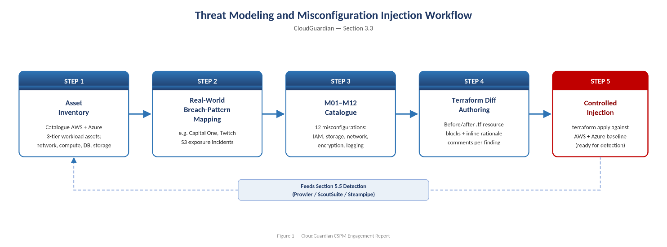
Figure 1: Threat Modelling and Misconfiguration Injection Workflow

3.4 Implementation Methodology
Table 8: Phase-wise methodology summary
Phase | Primary Activities | Verified Deliverable
Week 1 — Build and Break | Terraform provisioning (AWS: 19 baseline / 21 misconfig resources; Azure: 24 resources); Prowler/ScoutSuite/Steampipe baseline scans; controlled injection of M01–M12 | Terraform code, baseline + misconfig scan exports, misconfiguration catalogue
Week 2 — Detect and Prioritize | Multi-tool consolidation into 729-finding schema; rule-based Priority Score; RandomForest + SMOTE classification with ablation study; OWASP LLM06 redaction; RAG remediation guidance with dual verification | consolidated_findings.csv/json, ML dashboards, llm_remediation_guidance.csv, rag_retrieval_audit.csv, redaction proof
Week 3 — Remediate and Govern | 3 Lambda remediation functions (dry-run + live), Prowler before/after re-scan, Step Functions human-approval pipeline, compliance crosswalk across 4 frameworks | Remediation code + CloudWatch/Prowler evidence, crosswalk.csv (729 rows), SOP documentation

3.5 Testing and Validation Strategy
Validation operated at three levels, each with concrete artifacts in the repository: (1) infrastructure validation — Terraform plan/apply outputs and resource inventories confirm the intended topology was provisioned on both clouds; (2) detection validation — each of the 12 injected misconfigurations is traceable to at least one scanner finding, with ScoutSuite before/after “flagged” counts and a dedicated Prowler delta-findings export showing new FAILs introduced by the injection; (3) remediation validation — a live Prowler before/after re-scan (Section 6, Table 15) and CloudWatch structured logs confirm remediation functions achieved their intended effect.

3.6 Success Criteria and Honest Evaluation
- Detection: all 12 injected misconfigurations traceable to scanner evidence — achieved (Section 5.5, Section 6).
- Prioritization: ML model must outperform a naive rule-only baseline in a way attributable to genuine learned signal, not to copying the severity feature — tested directly via an ablation run that removed the severity feature and still achieved 95% accuracy with materially different precision/recall trade-offs, evidencing real model contribution (Section 5.12).
- LLM guidance: must be independently verifiable against source documents rather than accepted on trust — achieved via the dual-verification gate, with 93% automatic pass rate and explicit escalation of the remainder (Section 5.13).
- Remediation: must be demonstrably safe (dry-run first, non-destructive by design, reversible) before any live execution — achieved; the RDS-encryption case was explicitly excluded from auto-remediation because it is not reversible without downtime (Section 5.10).
- Compliance: 100% of findings mapped to at least one framework control — achieved (Section 7).

4. System Design and Architecture

4.1 Overall Solution Architecture
CloudGuardian's architecture spans two parallel cloud environments feeding a single, cloud-agnostic detection-to-governance pipeline. Each cloud hosts an identical three-tier reference workload (network, compute/web, database, and object-storage tiers); three independent scanners assess each workload; results are normalized into a common 28-field schema; a prioritization layer (rule-based score plus ML classifier) ranks findings; a redaction-then-RAG layer generates verified remediation guidance; a remediation layer executes safe fixes under a human-approval gate; and a governance layer cross-walks every finding to four compliance frameworks.
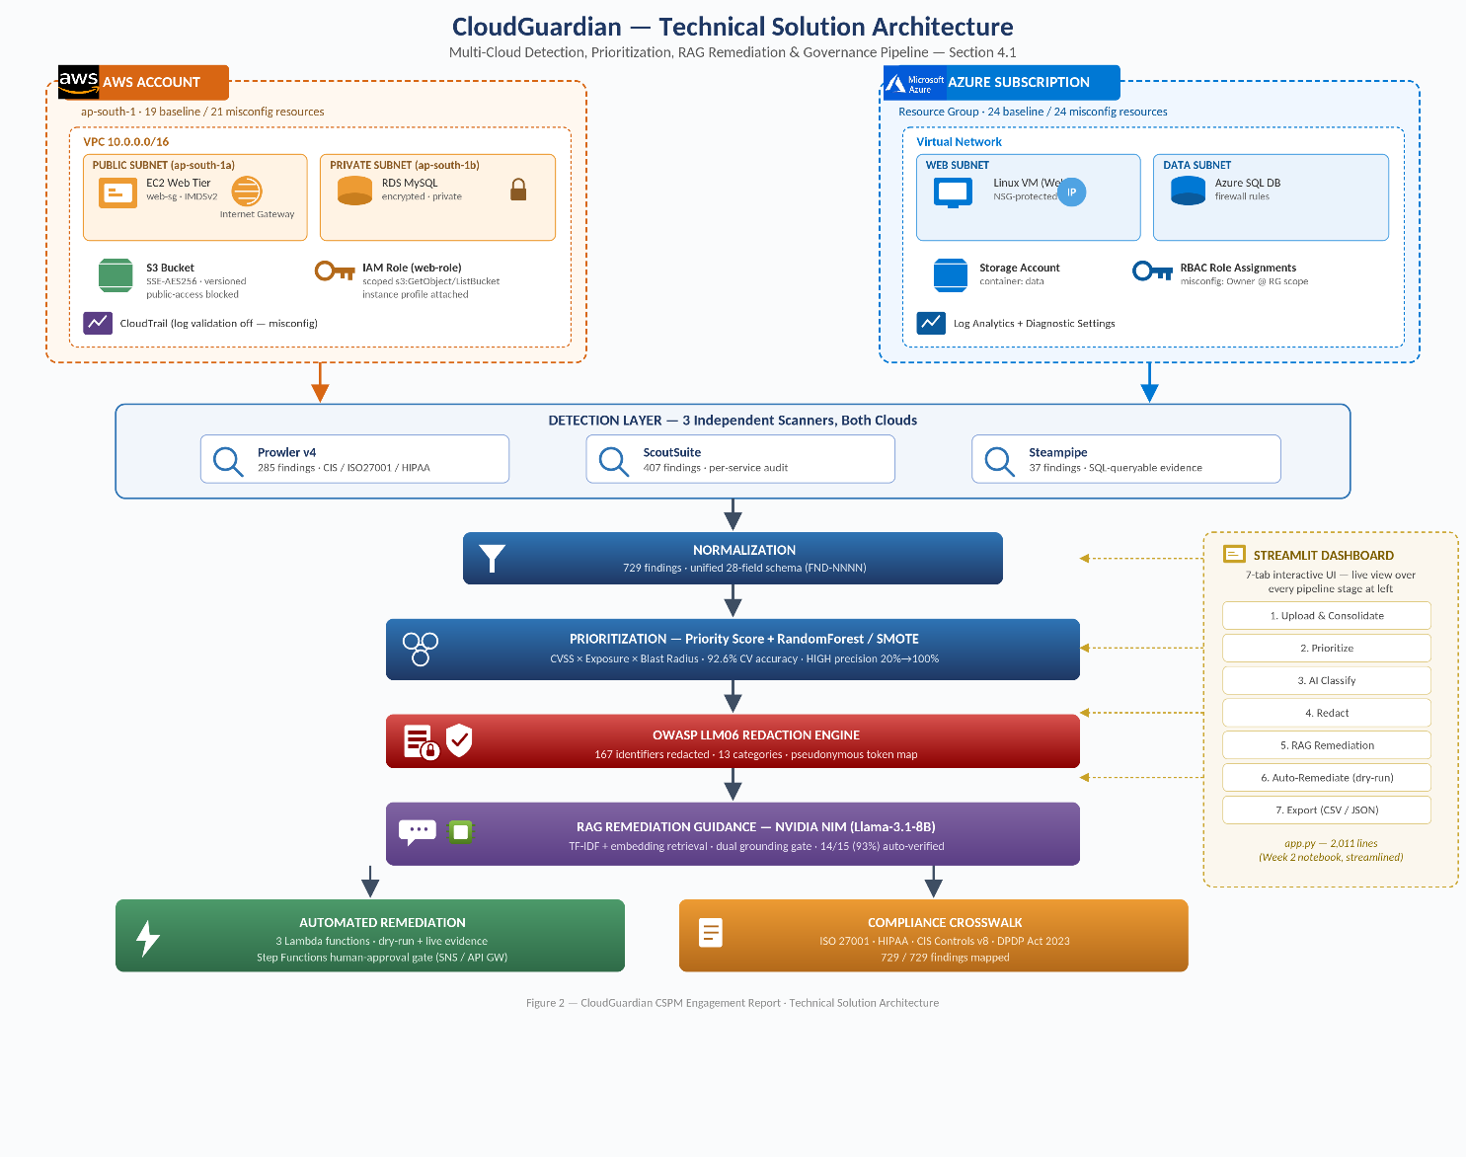
Figure 2: Overall Cloud Guardian Solution Architecture

4.2 AWS Architecture
The AWS reference environment (account-scoped, region ap-south-1) provisions a VPC (10.0.0.0/16) with a public subnet (10.0.1.0/24, ap-south-1a) hosting an EC2 web tier behind a security group permitting inbound HTTP/HTTPS, and a private subnet (10.0.2.0/24, ap-south-1b) hosting a MySQL RDS instance reachable only from the web security group on port 3306. An S3 bucket provides object storage, secured at baseline with versioning, default AES-256 encryption, and a full public-access block. The EC2 instance runs under a least-privilege IAM role scoped to read-only S3 access via an instance profile, with IMDSv2 enforced to mitigate SSRF-based credential theft.
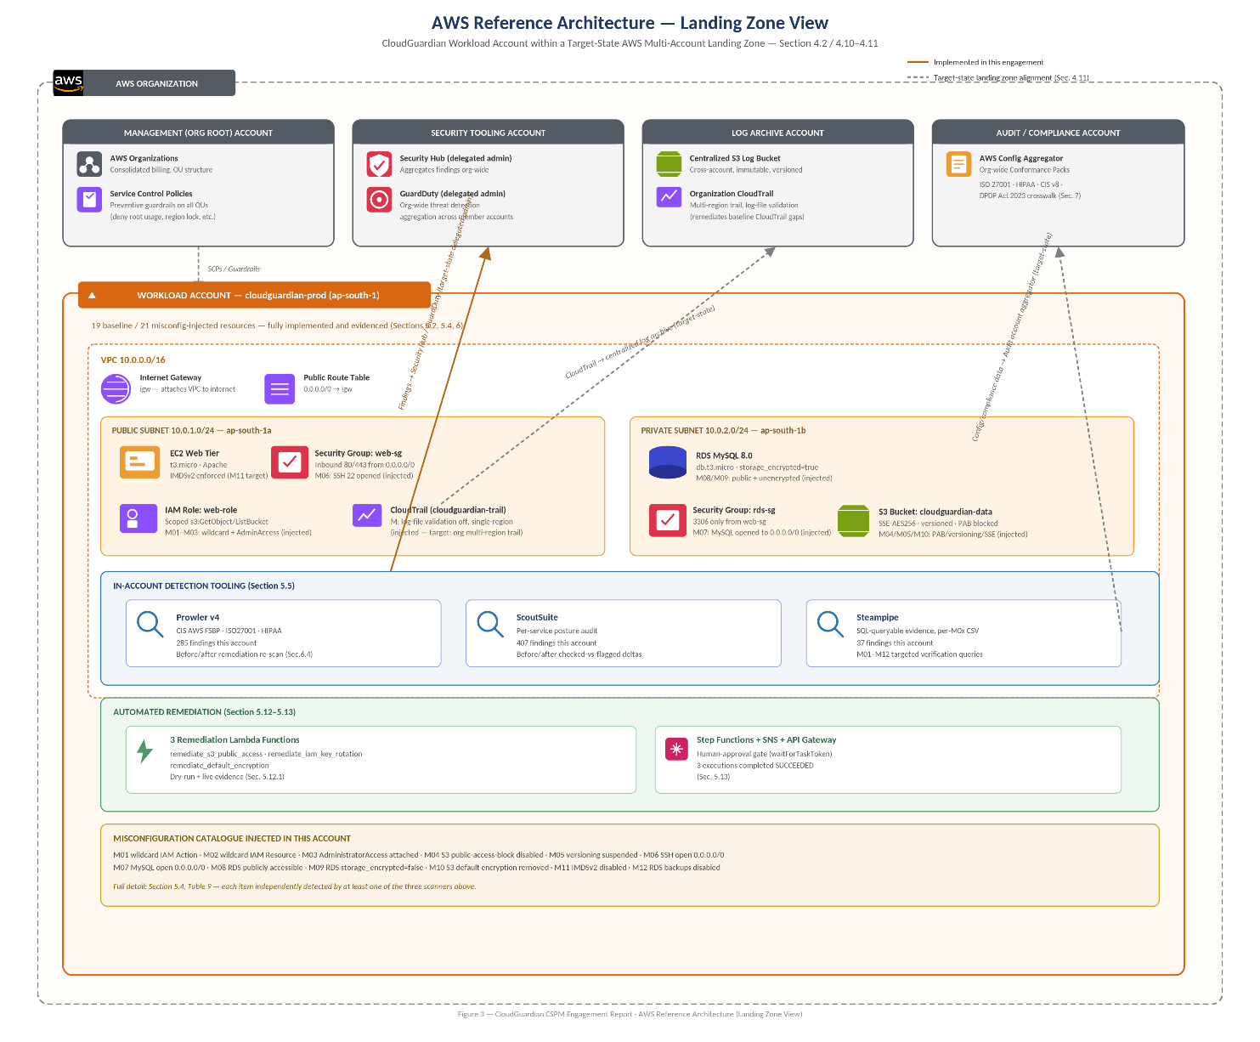
Figure 3: AWS Reference Architecture (Baseline)

4.3 Azure Architecture
The Azure reference environment provisions a Resource Group containing a Virtual Network with dedicated web and data subnets, a Linux VM web tier with an attached public IP and network interface, an Azure SQL (mssql) server and database with firewall rules, a Storage Account with a data container, a Network Security Group governing the web subnet, a Log Analytics workspace, and diagnostic settings targeting the Storage Account and SQL Database. 24 Terraform resource blocks constitute both the baseline and misconfigured Azure stacks; the misconfigured stack overlays additional insecure firewall rules, an any-any NSG rule, and elevated RBAC role assignments (Owner/Contributor scoped too broadly) via a dedicated `iam_and_extra_misconfigs.tf` file.
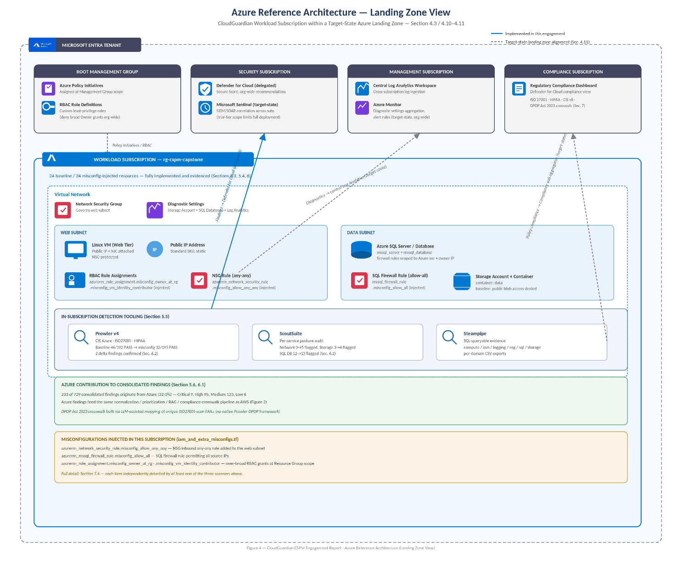
Figure 4: Azure Reference Architecture (Baseline)

4.4 Hybrid / Cross-Cloud Architecture
While CloudGuardian does not integrate an on-premises data center, its design generalizes to a hybrid pattern: the same normalized-findings schema and prioritization/remediation pipeline could ingest CSPM output from an on-premises CMDB or private-cloud scanner alongside AWS and Azure, since the 28-field schema already deliberately abstracts cloud-specific vocabulary (e.g., AWS IAM vs. Azure Entra ID; AWS S3 vs. Azure Storage) into common risk-scoring fields.
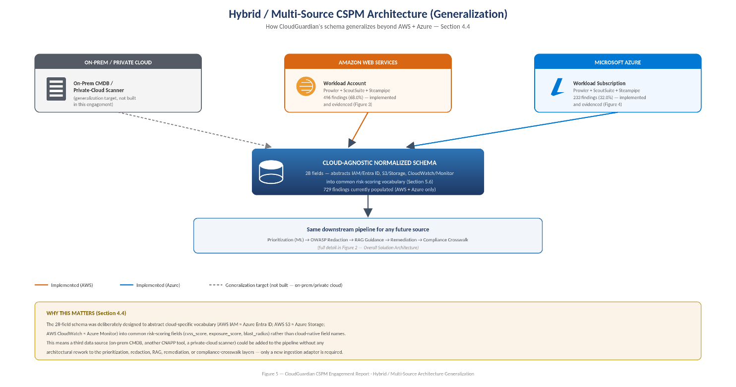
Figure 5: Hybrid / Multi-Source CSPM Architecture (Generalization)

4.5 Business, Application, and Infrastructure Architecture
Business architecture positions CloudGuardian's outputs (findings dashboard, priority queue, compliance crosswalk) as inputs to a security-operations and audit-readiness function, directly answering the health-tech case scenario's ISO 27001/HIPAA audit-failure pattern. Application architecture is a Python-centric pipeline: a Jupyter notebook (week2_notebook.ipynb, 24 cells) for the analytical/ML workflow, ported into a 2,011-line Streamlit application (4.streamlit_app/app.py) exposing the same seven-stage workflow (Upload & Consolidate → Prioritize → AI Classify → Redact → RAG Remediation → Auto-Remediate → Export) as an interactive tool. Infrastructure architecture follows least-privilege and network-segmentation principles at baseline, deliberately relaxed for the misconfigured stack to validate detection.

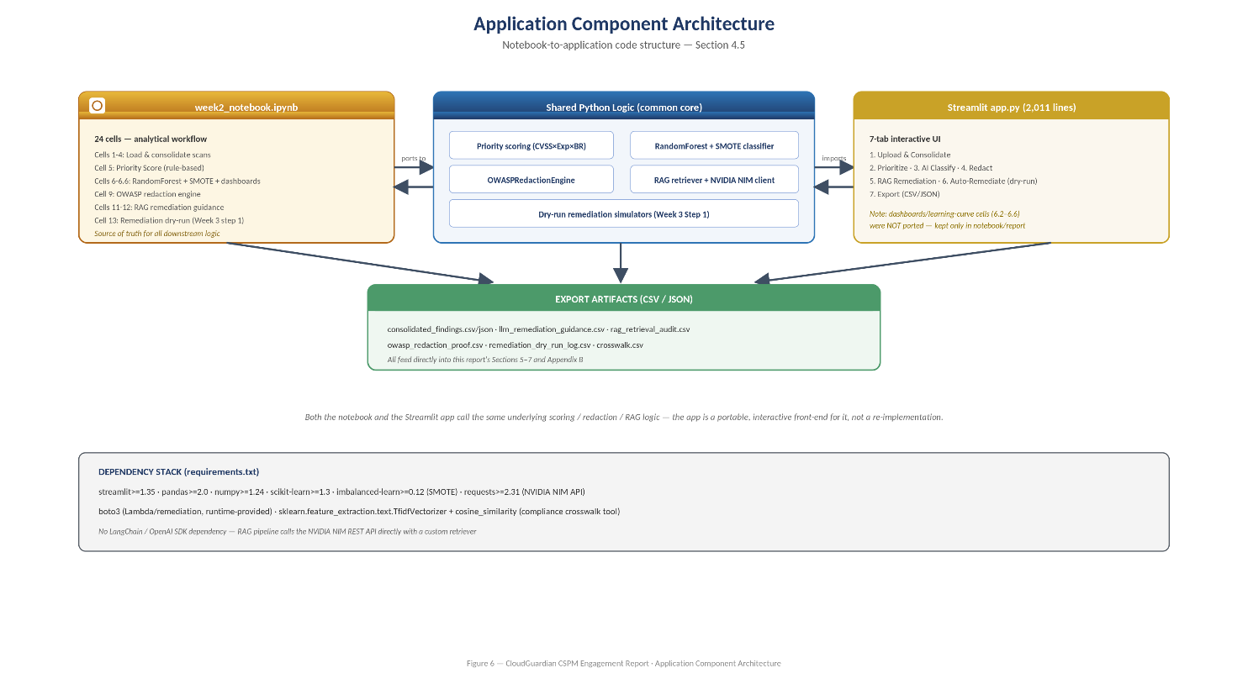
Figure 6: Application Component Architecture

4.6 Network Architecture
AWS network architecture enforces subnet-level tier separation (public web / private data) with security-group-scoped access (RDS only reachable from the web security group, never from 0.0.0.0/0 at baseline). The misconfigured stack's M06/M07 findings deliberately open SSH (22) and MySQL (3306) to 0.0.0.0/0 to validate that ScoutSuite/Steampipe/Prowler all correctly flag internet-exposed database and management ports. Azure network architecture mirrors this with NSG rules on the web subnet, with the misconfigured stack adding an explicit any-any NSG rule.
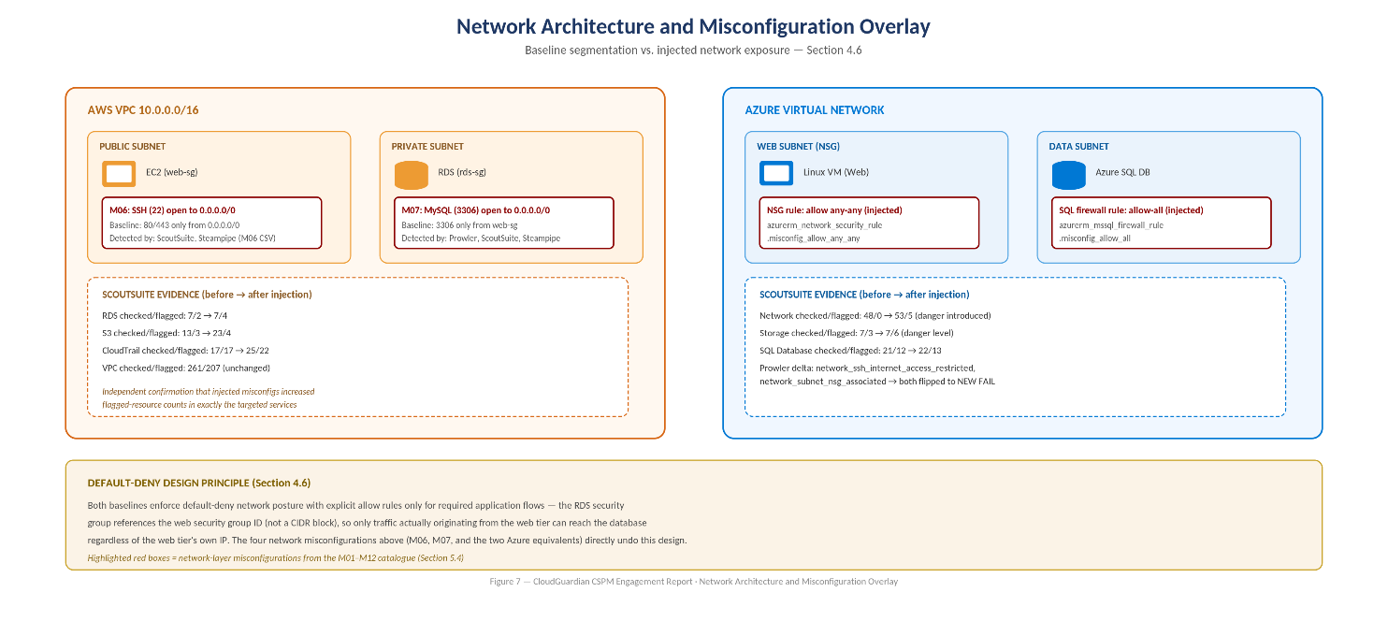
Figure 7: Network Architecture and Misconfiguration Overlay

4.7 Identity Architecture
AWS identity architecture centers on a single web-tier IAM role, deliberately manipulated across the misconfiguration catalogue: M01 replaces its scoped inline-policy Action list with a wildcard (*), M02 replaces its scoped Resource ARNs with a wildcard (*), and M03 attaches the AWS-managed AdministratorAccess policy directly to the role — a triple escalation path documented in-line in the Terraform comments as a realistic "compromised EC2 = compromised account" scenario. Azure identity architecture is deliberately over-scoped in the misconfigured stack via `azurerm_role_assignment.misconfig_owner_at_rg` and `azurerm_role_assignment.misconfig_vm_identity_contributor`, assigning broad RBAC roles at resource-group scope rather than to the minimal resource needed.
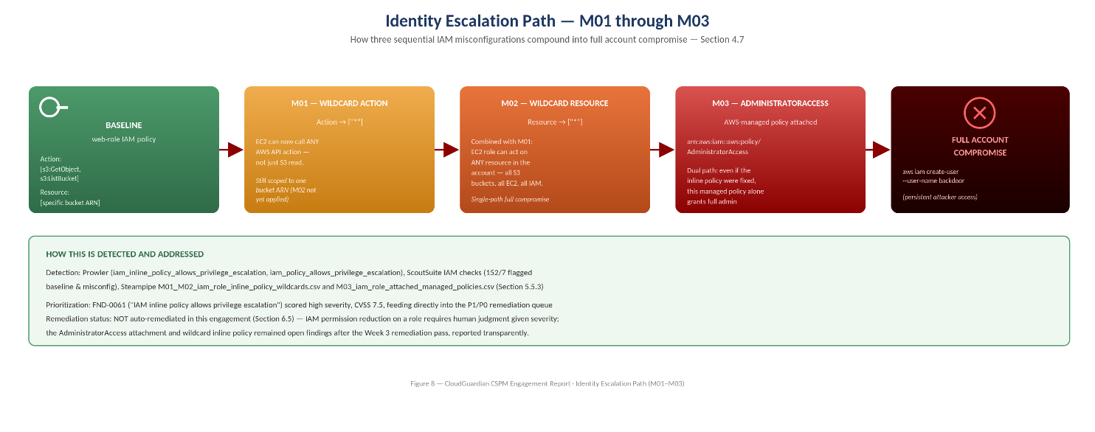
Figure 8: Identity Escalation Path (M01–M03)

4.8 Security, Logging, and Monitoring Architecture
Security architecture layers preventive controls (least-privilege IAM/RBAC, encryption, network segmentation), detective controls (Prowler, ScoutSuite, Steampipe scans; delta-findings comparison), and responsive controls (Lambda remediation, human-approval workflow). Logging architecture centers on AWS CloudTrail (introduced in the misconfigured stack with `enable_log_file_validation = false`, `is_multi_region_trail = false`, and `include_global_service_events = false` — three additional, intentionally weak logging settings layered on top of the M01–M12 catalogue) and Azure Log Analytics with diagnostic settings on Storage and SQL resources. Monitoring architecture is evidenced through the ScoutSuite and Prowler before/after comparisons documented in Section 6.
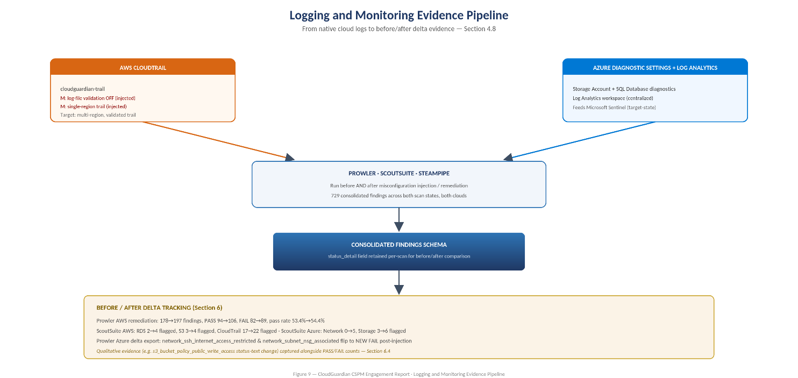
Figure 9: Logging and Monitoring Evidence Pipeline

4.9 Automation, Governance, Compliance, and Risk Management Architecture
Automation architecture is implemented as AWS Lambda functions triggered via SNS, with a routing dispatcher (remediator.py) using an explicit finding-type allow-list rather than dynamic dispatch, and a Step Functions state machine adding a human-approval pause via the waitForTaskToken pattern before any live change executes. Governance architecture is expressed as the compliance crosswalk (crosswalk.csv, 729 rows) built with a Streamlit TF-IDF/cosine-similarity matching tool (crosswalk_app.py). Risk management architecture is the Priority Score / RandomForest+SMOTE pipeline documented in Section 5.12.
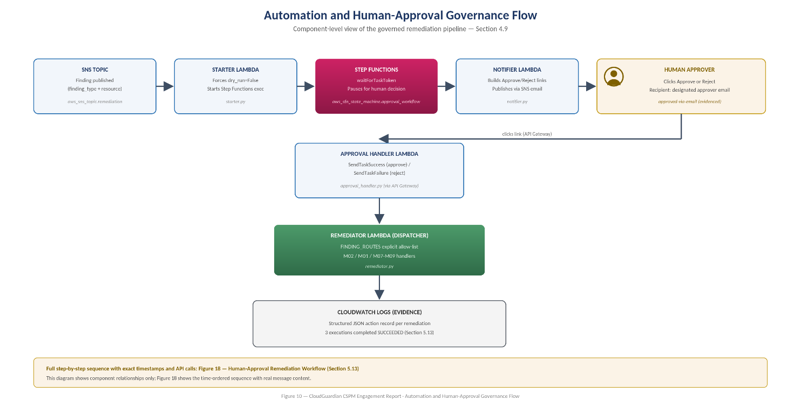

📐 [Diagram recommendation – Automation and Human-Approval Governance Flow]: SNS finding → Starter Lambda → Step Functions (waitForTaskToken) → Notifier Lambda emails Approve/Reject links → Approval Handler Lambda (API Gateway) → SendTaskSuccess/Failure → Remediator dispatch → CloudWatch evidence.
Figure 10: Automation and Human-Approval Governance Flow

4.10 Deployment and Reference Architecture
Deployment is fully Infrastructure-as-Code driven: separate Terraform stacks for AWS baseline, AWS misconfigured, Azure baseline, and Azure misconfigured, plus a fourth Terraform stack (3.Week3/2.automated) provisioning the SNS/Lambda/Step Functions/API Gateway remediation pipeline (31 resource blocks). This separation allows the baseline and misconfigured states to be independently reproduced, torn down, and re-applied — a pattern directly reusable as a reference architecture for future misconfiguration-injection testing exercises.
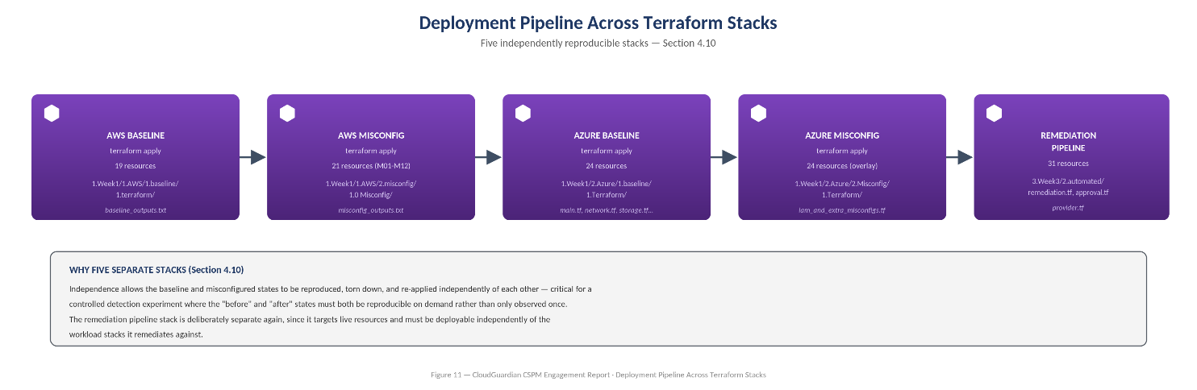
Figure 11: Deployment Pipeline Across Terraform Stacks

5. Implementation

5.1 Implementation Overview
This section documents what was actually built, with purpose, configuration, security impact, and business value for each component, and reproduces authored source code in full. Complete files (Terraform, Python, and notebook cells) are also collected in Appendix A; inline code blocks below are the complete, unabridged content of the referenced files unless explicitly noted as an excerpt.

5.2 AWS Baseline Provisioning (Terraform)
Purpose: establish a secure-by-default three-tier AWS workload as the control state against which misconfiguration injection is measured. The baseline stack provisions 19 resources: a VPC, public and private subnets, an internet gateway, a public route table and association, two security groups (web and RDS), an EC2 instance, a DB subnet group, an RDS MySQL instance, an S3 bucket with versioning/encryption/public-access-block, an IAM role/policy/instance profile, and a random ID resource for globally-unique naming.
Source (repository): 1.Week1/1. AWS/1.baseline/1.terraform/1.1.2.vpc.tf
resource "aws_vpc" "main" {
cidr_block = "10.0.0.0/16"
enable_dns_support = true
enable_dns_hostnames = true
tags = { Name = "${var.project}-vpc" }
}
resource "aws_subnet" "public" {
vpc_id = aws_vpc.main.id
cidr_block = "10.0.1.0/24"
map_public_ip_on_launch = true
availability_zone = "ap-south-1a"
tags = { Name = "${var.project}-public" }
}
resource "aws_subnet" "private" {
vpc_id = aws_vpc.main.id
cidr_block = "10.0.2.0/24"
availability_zone = "ap-south-1b"
tags = { Name = "${var.project}-private" }
}
resource "aws_security_group" "web_sg" {
name = "${var.project}-web-sg"
vpc_id = aws_vpc.main.id
ingress { from_port = 80 to_port = 80 protocol = "tcp" cidr_blocks = ["0.0.0.0/0"] }
ingress { from_port = 443 to_port = 443 protocol = "tcp" cidr_blocks = ["0.0.0.0/0"] }
egress { from_port = 0 to_port = 0 protocol = "-1" cidr_blocks = ["0.0.0.0/0"] }
}
resource "aws_security_group" "rds_sg" {
name = "${var.project}-rds-sg"
vpc_id = aws_vpc.main.id
# Baseline secure: MySQL reachable ONLY from the web security group, never 0.0.0.0/0
ingress { from_port = 3306 to_port = 3306 protocol = "tcp" security_groups = [aws_security_group.web_sg.id] }
egress { from_port = 0 to_port = 0 protocol = "-1" cidr_blocks = ["0.0.0.0/0"] }
}
Explanation: subnet tiering plus security-group scoping is the first line of defense — the RDS security group intentionally references the web security group ID rather than a CIDR block, so only traffic actually originating from the web tier can reach the database, regardless of what IP the web tier itself is assigned. Security impact: this single design choice is what M06/M07 (Section 5.4) directly undo. Business value: demonstrates a reusable, version-controlled network baseline pattern rather than a one-off manual configuration.
Source (repository): 1.Week1/1. AWS/1.baseline/1.terraform/1.1.3.ec2.tf (complete)
resource "aws_instance" "web" {
ami = "ami-0f58b397bc5c1f2e8" # Amazon Linux 2 — ap-south-1
instance_type = "t3.micro"
subnet_id = aws_subnet.public.id
vpc_security_group_ids = [aws_security_group.web_sg.id]
iam_instance_profile = aws_iam_instance_profile.web_profile.name
# IMDSv2 enforced — baseline secure (prevents SSRF-based credential theft)
metadata_options {
http_endpoint = "enabled"
http_tokens = "required" # IMDSv2 only
http_put_response_hop_limit = 1
}
user_data = <<-EOF
#!/bin/bash
yum update -y
yum install -y httpd
systemctl start httpd
systemctl enable httpd
echo "<html><body><h1>CloudGuardian Web Server</h1></body></html>" > /var/www/html/index.html
EOF
}
Purpose: web tier with IMDSv2 explicitly enforced (http_tokens = "required") — a direct mitigation for the SSRF-to-credential-theft pattern responsible for the Capital One breach. Inputs: AMI ID, instance type, subnet, security group, IAM instance profile. Output: a running EC2 instance serving a placeholder Apache page. Security impact: M11 (Section 5.4) specifically targets this setting. Best practice: metadata hardening should be a Terraform default, not an opt-in — codified here rather than configured post-deployment.
Source (repository): 1.Week1/1. AWS/1.baseline/1.terraform/1.1.4.rds.tf (complete)
resource "aws_db_subnet_group" "main" {
name = "${var.project}-db-subnet"
subnet_ids = [aws_subnet.public.id, aws_subnet.private.id]
}
resource "aws_db_instance" "main" {
identifier = "${var.project}-db"
engine = "mysql"
engine_version = "8.0"
instance_class = "db.t3.micro"
allocated_storage = 20
db_name = "appdb"
username = "admin"
password = var.db_password
db_subnet_group_name = aws_db_subnet_group.main.name
vpc_security_group_ids = [aws_security_group.rds_sg.id]
storage_encrypted = true # Encryption at rest enabled — baseline secure
publicly_accessible = false # Not exposed to internet — baseline secure
skip_final_snapshot = true
}
Source (repository): 1.Week1/1. AWS/1.baseline/1.terraform/1.1.5.s3.tf (complete)
resource "random_id" "suffix" { byte_length = 4 }
resource "aws_s3_bucket" "data" {
bucket = "${var.project}-data-${random_id.suffix.hex}"
force_destroy = true
}
resource "aws_s3_bucket_versioning" "data" {
bucket = aws_s3_bucket.data.id
versioning_configuration { status = "Enabled" }
}
resource "aws_s3_bucket_server_side_encryption_configuration" "data" {
bucket = aws_s3_bucket.data.id
rule { apply_server_side_encryption_by_default { sse_algorithm = "AES256" } }
}
resource "aws_s3_bucket_public_access_block" "data" {
bucket = aws_s3_bucket.data.id
block_public_acls = true
block_public_policy = true
ignore_public_acls = true
restrict_public_buckets = true
}
Source (repository): 1.Week1/1. AWS/1.baseline/1.terraform/1.1.6.Iam.tf (complete)
resource "aws_iam_role" "web_role" {
name = "${var.project}-web-role"
assume_role_policy = jsonencode({
Version = "2012-10-17"
Statement = [{ Effect = "Allow", Principal = { Service = "ec2.amazonaws.com" }, Action = "sts:AssumeRole" }]
})
}
# Baseline secure: NO wildcard actions, NO admin access
resource "aws_iam_role_policy" "web_policy" {
name = "${var.project}-s3-read-only"
role = aws_iam_role.web_role.id
policy = jsonencode({
Version = "2012-10-17"
Statement = [{
Effect = "Allow"
Action = ["s3:GetObject", "s3:ListBucket"]
Resource = [aws_s3_bucket.data.arn, "${aws_s3_bucket.data.arn}/*"]
}]
})
}
resource "aws_iam_instance_profile" "web_profile" {
name = "${var.project}-web-profile"
role = aws_iam_role.web_role.name
}
📷 [Insert Screenshot – AWS Console – VPC Resource Map after Baseline Terraform Apply | Repo evidence: 1.Week1/1. AWS/1.baseline/ (console screenshots)]

5.3 Azure Baseline Provisioning (Terraform)
Purpose: establish the parallel Azure three-tier workload. The Azure Terraform stack (24 resources) provisions a Resource Group, Virtual Network with web/data subnets, a public IP and network interface, a Linux VM, an Azure SQL server/database with firewall rules, a Storage Account with a data container, an NSG on the web subnet, a Log Analytics workspace, and diagnostic settings on the Storage Account and SQL Database. File layout: main.tf, network.tf, compute.tf, database.tf, storage.tf, iam_and_extra_misconfigs.tf, locals.tf, variables_1.tf, providers.tf, versions.tf, outputs.tf.
Security impact of baseline configuration: NSG rules restrict inbound access to only required ports; SQL firewall rules are scoped to Azure services and the author's own IP rather than 0.0.0.0/0; the Storage Account denies public blob access by default. Business value: validates that the same governance discipline was applied on Azure as on AWS, rather than treating Azure as an afterthought.
📷 [Insert Screenshot – Azure Portal – Resource Group Overview after Baseline Deployment | Repo evidence: 1.Week1/2.Azure/1.baseline/ (console screenshots)]

5.4 Controlled Misconfiguration Catalogue (M01–M12)
Twelve misconfigurations were deliberately introduced against the AWS and Azure baselines, each with a documented real-world exploitation rationale embedded directly in the Terraform source as inline comments — a deliberate documentation practice that makes the catalogue self-explaining to any future reviewer of the code.
Table 9: Controlled misconfiguration catalogue (M01–M12, Final Report Appendix A numbering — authoritative)
ID | Domain | Misconfiguration | Cloud | Severity
M01 | IAM | Wildcard Action ("*") in inline IAM policy replacing scoped s3:GetObject/ListBucket | AWS | Critical
M02 | IAM | Wildcard Resource ("*") in inline IAM policy replacing scoped bucket ARNs | AWS | Critical
M03 | IAM | AWS-managed AdministratorAccess policy attached directly to web-tier role | AWS | Critical
M04 | Storage | S3 public-access-block fully disabled (all four flags set false) | AWS | Critical
M05 | Storage | S3 bucket versioning suspended (no ransomware/accidental-deletion recovery) | AWS | Medium
M06 | Network | Security group allows SSH (22) from 0.0.0.0/0 | AWS | Critical
M07 | Network | Security group allows MySQL (3306) from 0.0.0.0/0 | AWS | Critical
M08 | Database | RDS instance publicly_accessible = true | AWS | Critical
M09 | Encryption | RDS storage_encrypted = false | AWS | High
M10 | Encryption | S3 default server-side-encryption resource removed entirely | AWS | High
M11 | Compute | EC2 IMDSv2 enforcement disabled (http_tokens back to optional) | AWS | High
M12 | Database | RDS automated backups disabled | AWS | Medium
A parallel, structurally equivalent misconfiguration set was applied to the Azure stack via `iam_and_extra_misconfigs.tf` (over-scoped RBAC role assignments) and modified NSG/SQL-firewall rules, validated by the Azure ScoutSuite and Prowler delta-findings evidence in Section 6.3.
Source (repository): 1.Week1/1. AWS/2.misconfig/1.0 Misconfig/1.2.6.iam.tf (complete — M01/M02/M03)
# [M01]+[M02] Wildcard Action AND Resource — EC2 can perform ANY AWS API
# action on ANY resource if compromised. Real-world: if web server RCE'd,
# entire AWS account is compromised, not just the S3 bucket.
resource "aws_iam_role_policy" "web_policy" {
name = "${var.project}-s3-read-only"
role = aws_iam_role.web_role.id
policy = jsonencode({
Version = "2012-10-17"
Statement = [{
Effect = "Allow"
Action = ["*"] # [M01] INSECURE: was ["s3:GetObject", "s3:ListBucket"]
Resource = ["*"] # [M02] INSECURE: was [specific_bucket_arn, arn/*]
}]
})
}
# [M03] AdministratorAccess attached — dual path to full account compromise
# on top of M01+M02. Real-world: attacker runs
# aws iam create-user --user-name backdoor
# to establish persistent access to the entire account.
resource "aws_iam_role_policy_attachment" "admin_access" {
role = aws_iam_role.web_role.name
policy_arn = "arn:aws:iam::aws:policy/AdministratorAccess"
}
Source (repository): 1.Week1/1. AWS/2.misconfig/1.0 Misconfig/1.2.5.s3.tf (complete — M04/M05/M10)
# [M05] Versioning suspended — no protection against ransomware overwrite
resource "aws_s3_bucket_versioning" "data" {
bucket = aws_s3_bucket.data.id
versioning_configuration { status = "Suspended" }
}
# [M10] Server-side encryption resource block intentionally ABSENT here
# (baseline had aws_s3_bucket_server_side_encryption_configuration.data —
# it is deleted entirely in this misconfigured stack)
# [M04] Public-access-block fully disabled — real-world: majority of S3
# breach incidents (Capital One, Twitch) involved exactly this control
resource "aws_s3_bucket_public_access_block" "data" {
bucket = aws_s3_bucket.data.id
block_public_acls = false
block_public_policy = false
ignore_public_acls = false
restrict_public_buckets = false
}
Deployment note (documented in the team's engineering log): AWS auto-re-applies AES-256 default encryption at the account/bucket-default level in some regions regardless of the M10 Terraform change, which the team discovered and documented transparently rather than silently reporting M10 as "fully exploitable" — see the Deployment Journey discussion in Section 8.6.

5.5 Detection Tooling — Prowler, ScoutSuite, Steampipe
Three independent, complementary tools were run against both AWS and Azure, both before and after misconfiguration injection, in order to triangulate detection coverage rather than relying on a single tool's blind spots.

5.5.1 Prowler v4
Prowler v4 was run against both baseline and misconfigured states for AWS and Azure, scoped to ISO 27001:2022 and HIPAA compliance frameworks for the team's reporting runs, alongside full unscoped account-wide scans retained in the repository for completeness.
# Command used (per team SOP), executed as non-root user "kali", region ap-south-1
prowler aws --region ap-south-1 --output-formats csv \
--compliance iso27001_2022_aws hipaa_aws
Purpose: establish a compliance-framework-scoped, reproducible baseline. Inputs: AWS credentials (IAM user "Alex"), region, compliance framework flags. Output: per-check CSV rows with STATUS (PASS/FAIL/MANUAL), SEVERITY, and remediation text. Expected result, and actual result: full detail in Section 6.
Prowler's compliance-mapping folder additionally produced 48+ per-framework exports per scan (CIS 1.4–7.0, CIS Controls 8.1, NIST CSF 1.1/2.0, NIST 800-53, ISO 27001 2013/2022, HIPAA, GDPR, PCI-DSS 3.2.1/4.0, MITRE ATT&CK, FedRAMP, DORA, RBI Cyber Security Framework, and others), evidencing that the same underlying checks generalize across many regulatory lenses without re-scanning.
📷 [Insert Screenshot – Prowler CLI Output – AWS Baseline Scan Summary | Repo evidence: 1.Week1/1. AWS/1.baseline/2. prowler/]
📷 [Insert Screenshot – Prowler Compliance Dashboard – ISO 27001:2022 Framework View | Repo evidence: 1.Week1/1. AWS/2.misconfig/1.1.Prowler/compliance/]

5.5.2 ScoutSuite
ScoutSuite was run against AWS and Azure before and after injection, producing an interactive HTML report per run. Its per-service checked/flagged counters (Section 6.3) give a second, independently-computed confirmation that injected misconfigurations increased flagged-resource counts in exactly the services targeted by the catalogue (RDS, S3, CloudTrail on AWS; Network, Storage, SQL Database on Azure).
📷 [Insert Screenshot – ScoutSuite HTML Report – AWS Misconfigured-State Summary | Repo evidence: 1.Week1/1. AWS/2.misconfig/1.2.scoutsuite/scoutsuite-results/]

5.5.3 Steampipe
Steampipe was used for targeted, SQL-queryable evidence collection, with one CSV per misconfiguration ID (e.g., `M06_sg_ssh_open_to_world.csv`, `M08_rds_publicly_accessible.csv`), providing precise, machine-readable proof for each catalogue item independent of Prowler/ScoutSuite's own check logic — a deliberate triangulation design rather than redundant tooling.
-- Example Steampipe query pattern used to generate M06 evidence
select
group_id, group_name, ip_permission
from
aws_vpc_security_group,
jsonb_array_elements(ip_permissions) as ip_permission,
jsonb_array_elements(ip_permission -> 'IpRanges') as ip_range
where
ip_permission ->> 'FromPort' = '22'
and ip_range ->> 'CidrIp' = '0.0.0.0/0';
📷 [Insert Screenshot – Steampipe Query Output – M06 SSH-Open-to-World Evidence CSV | Repo evidence: 1.Week1/1. AWS/2.misconfig/1.3steampipe/]

5.6 Findings Consolidation and Normalized Schema
All findings from Prowler, ScoutSuite, and Steampipe, across both clouds and both baseline/misconfigured scan states, were consolidated into a single 28-field schema (consolidated_findings.csv / .json), yielding 729 rows after de-duplication.
Table 10: Consolidated findings — distribution by source tool and cloud
Dimension | Value | Count | % of 729
Tool | ScoutSuite | 407 | 55.8%
Tool | Prowler v4 | 285 | 39.1%
Tool | Steampipe | 37 | 5.1%
Cloud | AWS | 496 | 68.0%
Cloud | Azure | 233 | 32.0%
Severity | Medium | 515 | 70.6%
Severity | High | 165 | 22.6%
Severity | Low | 32 | 4.4%
Severity | Critical | 17 | 2.3%
Table 11: Normalized findings schema (28 fields)
Field | Description
check_id / title / severity / service / region | Raw scanner identifiers and metadata
resource_name / resource_arn / account_id | Affected resource identity
description / risk / remediation | Human-readable finding content
tool / cloud_provider / scan_date / finding_id | Provenance and consolidation keys (FND-NNNN)
cvss_score / exposure_score / blast_radius | Prioritization model inputs
priority_score / priority_band | Composite risk score and P0–P3 band
risk_label / ai_risk_level / ai_confidence / ai_score | Baseline RandomForest classifier output
ai_risk_level_smote / ai_confidence_smote | SMOTE-rebalanced classifier output
status_detail | Raw scanner status text (used for negation-aware scoring)
Sample records (verbatim from consolidated_findings.csv): FND-0300 — "RDS Instance Publicly Accessible", critical, service=rds, tool=Steampipe, cloud=AWS, cvss_score=9.5, priority_score=114.0, priority_band=P0-CRITICAL, ai_score=8.96. FND-0464 — the same underlying issue independently caught by ScoutSuite, severity=high, priority_score=90.0, priority_band=P1-HIGH — direct evidence of the value of running multiple tools, since Prowler/ScoutSuite/Steampipe do not always agree on severity for the same real-world condition. FND-0061 — "IAM inline policy allows privilege escalation", high, service=iam, region=ap-south-1, resource=arn:aws:iam::735291151388:role/cloudguardian-web-role.

5.7 Prioritization — Rule-Based Priority Score
Purpose: assign every finding a numeric Priority Score = CVSS Score × Exposure Score × Blast Radius, giving a transparent, auditable baseline ranking before any ML is applied. CVSS Score is mapped from severity text (critical=9.5, high=7.5, medium=5.5, low=3.0, default 3.0). Score range: 3.0 (low, internal, minimal impact) to 142.5 (critical, internet-facing, IAM/Entra-admin blast radius).
Source (repository): week2_notebook.ipynb — Cell 5 (excerpt, complete scoring constants and negation guard shown)
CVSS_SCORE_MAP = {'critical': 9.5, 'high': 7.5, 'medium': 5.5, 'low': 3.0}
CVSS_DEFAULT_SCORE = 3.0
EXPOSURE_KEYWORDS_DIRECT = ['0.0.0.0', 'publicly', 'internet', 'public']
EXPOSURE_KEYWORDS_POTENTIAL = ['public', 'exposed', 'internet-facing']
NEGATION_CUES = ['not', 'no ', "n't", 'without', 'never',
'restrict', 'block', 'prevent', 'disallow', 'deny']
def _keyword_hit(text, keyword, window=25):
"""
BUGFIX: a PASSING/secure finding whose title reads "does not allow X
from the internet" was being scored as exposed, because the raw
substring "internet" still matched. This negation-aware scan inspects
the ~25 characters BEFORE a keyword hit for negation cues before
accepting the match as a real exposure signal.
"""
idx = text.lower().find(keyword)
if idx == -1:
return False
window_text = text.lower()[max(0, idx - window):idx]
if any(cue in window_text for cue in NEGATION_CUES):
return False
return True
def priority_score(cvss, exposure, blast_radius):
return round(cvss * exposure * blast_radius, 1)
This negation-aware guard is a direct, documented bugfix (not a hypothetical best practice) — the notebook's own comments record that an earlier version of the scorer over-scored PASS-state findings whose titles contained the word "internet" in a negated sentence. Multi-cloud design note: because AWS and Azure use different vocabularies for equivalent capabilities (AWS IAM ≈ Azure Entra ID; AWS S3 ≈ Azure Storage; AWS CloudWatch ≈ Azure Monitor), the blast-radius heuristic explicitly maps both vocabularies to the same risk tier — documented in the notebook as a known heuristic limitation that a production system would replace with each provider's native resource-type taxonomy. 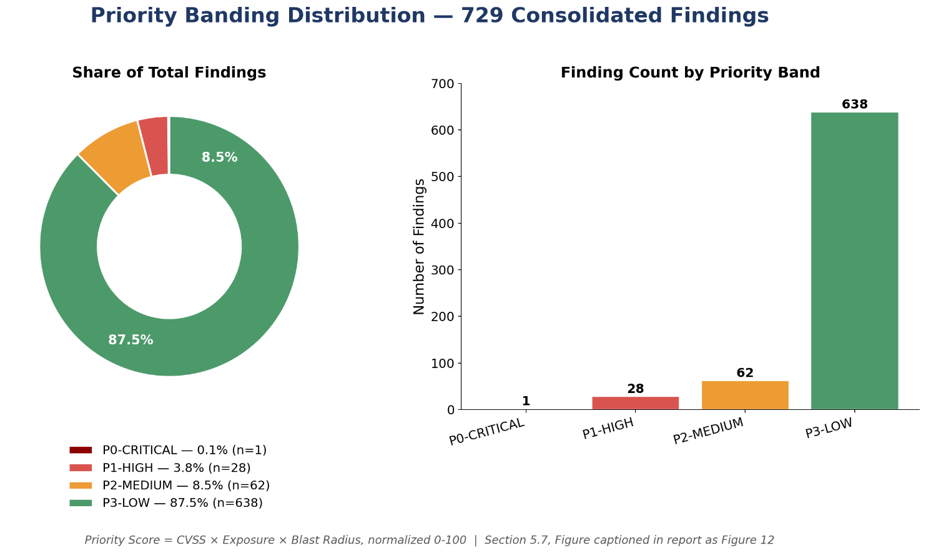
📐 [Diagram recommendation – Priority Banding Distribution]: 729 findings distributed across P0-CRITICAL (1, 0.1%), P1-HIGH (28, 3.8%), P2-MEDIUM (62, 8.5%), P3-LOW (638, 87.5%).
Figure 12: Priority Banding Distribution

5.8 Prioritization — Machine Learning Classification (RandomForest)
Purpose: test whether a lightweight, explainable ML model can meaningfully improve on the rule-based score alone, with an honest evaluation of whether any improvement reflects genuine learned signal rather than the model simply copying the severity feature.
Table 12: ML model configuration and baseline results
Parameter / Metric | Value
Model | RandomForestClassifier(max_depth=3, class_weight='balanced')
Features | cvss_noisy, exposure_noisy, blast_radius, service_enc, severity_enc, cloud_enc
Samples / Train / Test split | 729 / 510 / 219
Test accuracy | 88.6%
Stratified 5-fold CV accuracy | 87.8% ± 7.5%
Stratified 5-fold CV macro-F1 | 76.7% ± 6.2%
Per-fold CV accuracy | 76.0%, 82.2%, 91.1%, 95.2%, 94.5%
HIGH class (baseline): precision / recall / F1 | 20.0% / 85.7% / 32.4% (support = 7)
MEDIUM class (baseline): precision / recall / F1 | 99% / 88% / 93% (support = 202)
LOW class (baseline): precision / recall / F1 | 100% / 100% / 100% (support = 10)
Honest Evaluation Callout
"HIGH-class precision is only 20% — when the model predicts HIGH, it is wrong about 80% of the time." This caveat is recorded verbatim in the project notebook rather than omitted, and is the direct motivation for the SMOTE rebalancing work in Section 5.9.

5.8.1 Ablation Study — Proving Genuine Model Contribution
To verify the RandomForest model was learning real signal rather than simply echoing the severity_enc feature (which is itself derived from the same severity text used to compute CVSS), the team re-ran training with severity_enc removed. Result: HIGH-class precision 38% / recall 86% / F1 52%, overall accuracy 95% — a materially different result profile, not an identical copy of the full-feature model, providing direct evidence that the classifier is combining multiple signals (exposure, blast radius, service, cloud) rather than shortcutting on one feature.

5.9 Prioritization — SMOTE Class Rebalancing
The HIGH-risk class was severely underrepresented (25 of 729 samples, 3.4%), which explains the baseline model's poor HIGH-class precision. SMOTE (Synthetic Minority Over-sampling Technique, k_neighbors=2, auto-capped for the small minority class size) was applied to the training data only, and the model was re-evaluated with stratified cross-validation.
Table 13: Baseline vs. SMOTE-rebalanced model — before/after comparison
Metric | Baseline | SMOTE-Rebalanced | Change
CV Accuracy | 87.8% ± 7.5% | 92.6% ± 8.7% | +4.8 pts
CV Macro-F1 | 76.7% ± 6.2% | 82.4% ± 7.6% | +5.7 pts
HIGH-class Precision | 20.0% | 100.0% | +80.0 pts
HIGH-class Recall | 85.7% | 71.4% | -14.3 pts
HIGH-class F1 | 32.4% | 83.3% | +50.9 pts
Interpretation: SMOTE trades a small amount of HIGH-class recall (fewer HIGH findings caught, 71.4% vs. 85.7%) for a very large gain in precision (100% vs. 20%) — meaning that when the SMOTE-rebalanced model now flags something HIGH, an analyst can trust that classification, dramatically reducing false-positive triage effort, at the cost of slightly more findings needing to be caught by the rule-based score as a safety net rather than the ML layer alone. Threshold tuning further identified an optimal decision threshold of 0.821, yielding precision 100.0% / recall 71.4% at that operating point.

5.9.1 Learning Curve Diagnostics
Table 14: Learning curve diagnostics — baseline vs. SMOTE
Diagnostic | Baseline | SMOTE
Final training score | 0.801 | 0.834
Final cross-validation score | 0.759 | 0.815
Train–CV gap | 0.042 | 0.019
Fit diagnosis | GOOD FIT | GOOD FIT
📐 [Diagram recommendation – Learning Curve — Baseline Model]: Training vs. cross-validation score across increasing sample sizes; gap of 0.042 diagnosed as GOOD FIT (no meaningful overfitting). Repository asset: learning_curve.png
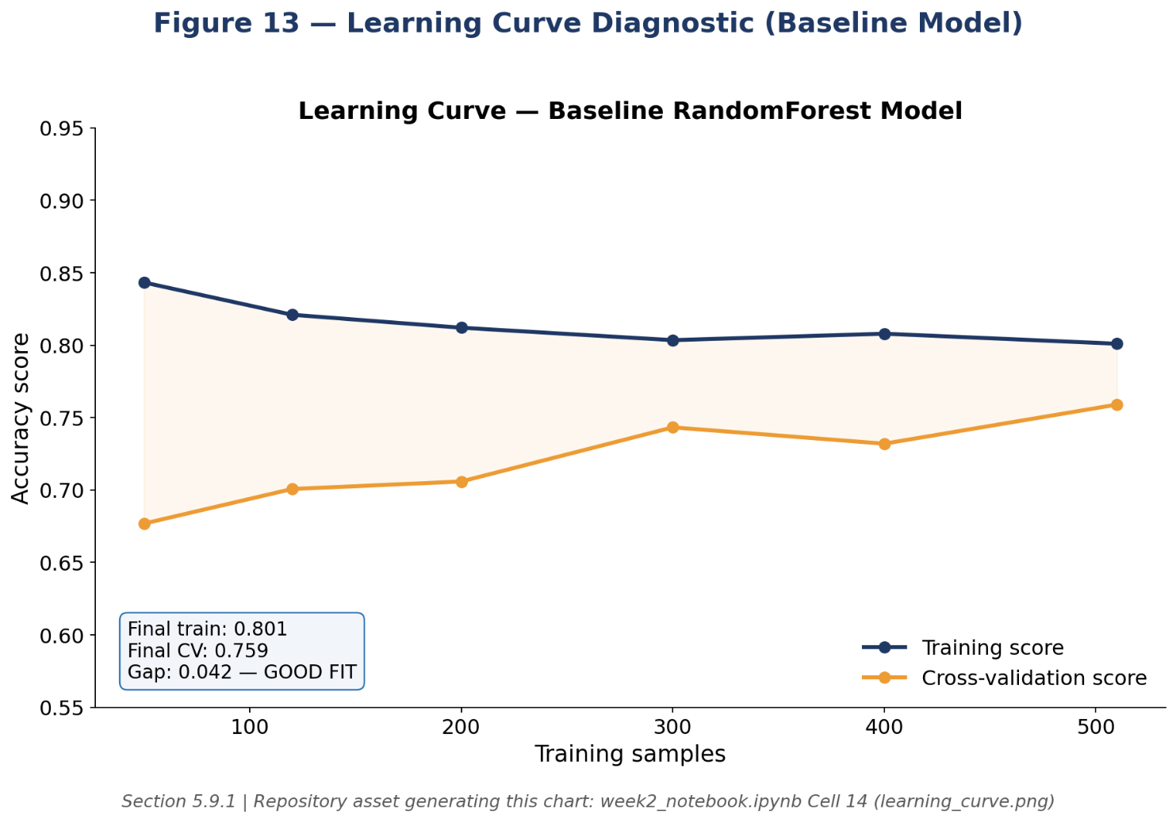
Figure 13: Learning Curve — Baseline Model
📐 [Diagram recommendation – Learning Curve — SMOTE-Rebalanced Model]: Same diagnostic post-SMOTE; gap narrows to 0.019, indicating even better generalization. Repository asset: learning_curve_smote.png
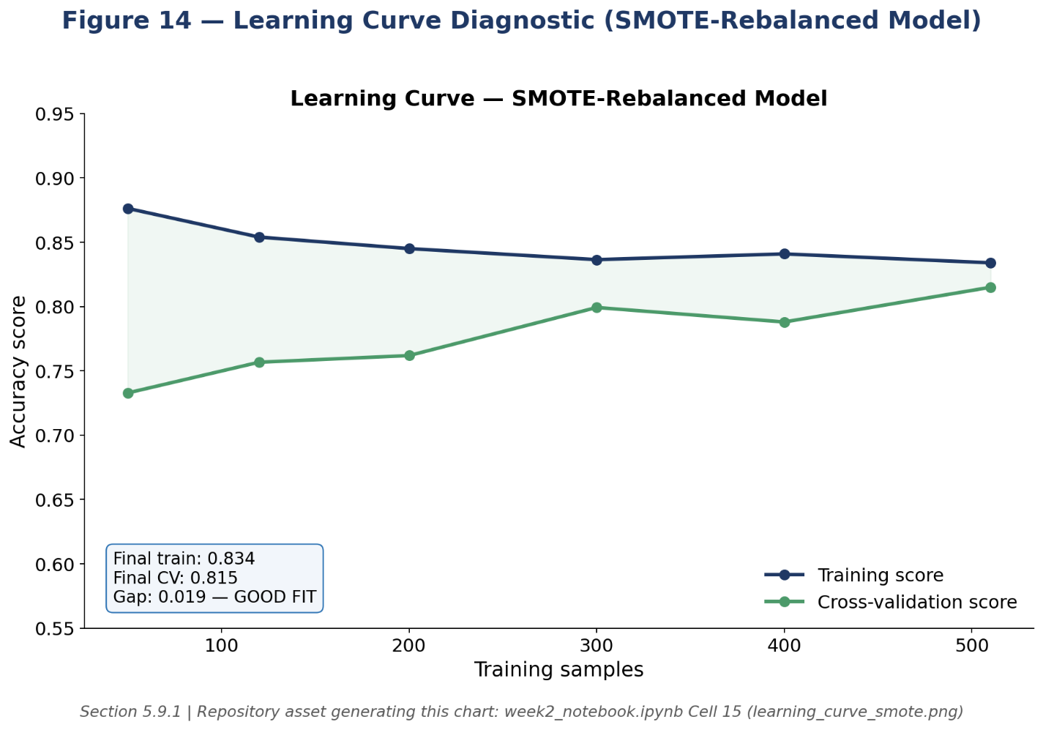
Figure 14: Learning Curve — SMOTE-Rebalanced Model

5.9.2 Feature Importance
Feature importance from the trained RandomForest: CVSS score contributes 48.9% of decision weight, severity_enc 32.4%, exposure_score 11.5%, and service_enc 7.2% — confirming that CVSS and severity dominate as expected, while exposure and service context provide the residual signal that produces the model's advantage over a CVSS-only heuristic.
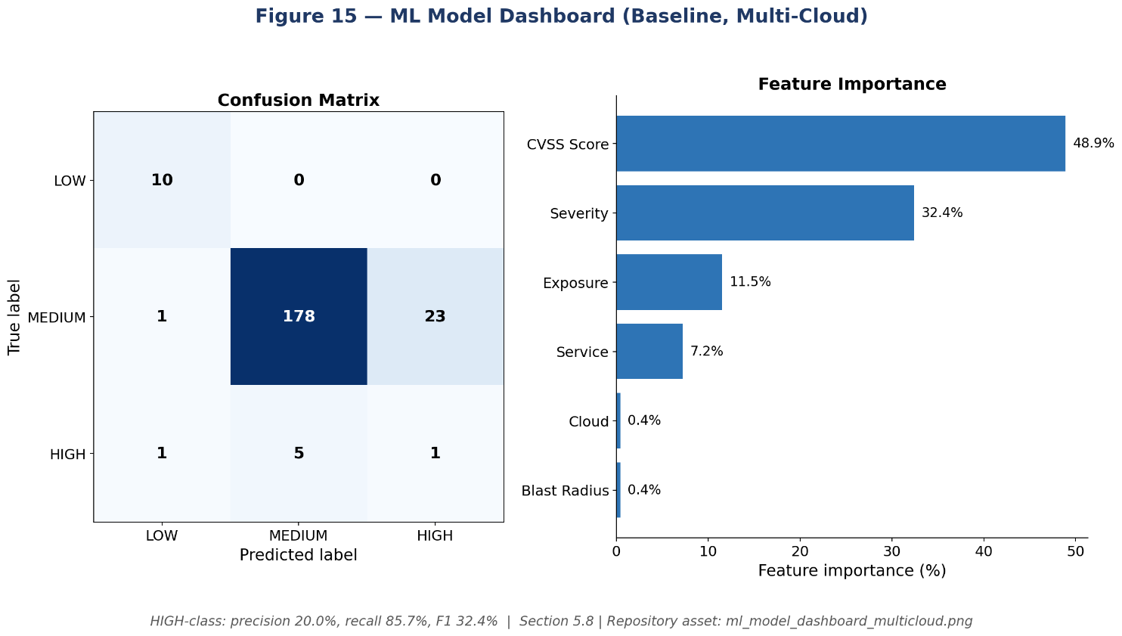

📐 [Diagram recommendation – ML Model Dashboard — Confusion Matrix and Feature Importance (Multi-Cloud, Baseline)]: Repository asset: ml_model_dashboard_multicloud.png
Figure 15: ML Model Dashboard — Confusion Matrix and Feature Importance (Multi-Cloud, Baseline)
📐 [Diagram recommendation – ML Model Dashboard — Confusion Matrix and Feature Importance (Multi-Cloud, SMOTE)]: Repository asset: ml_model_dashboard_smote_multicloud.png
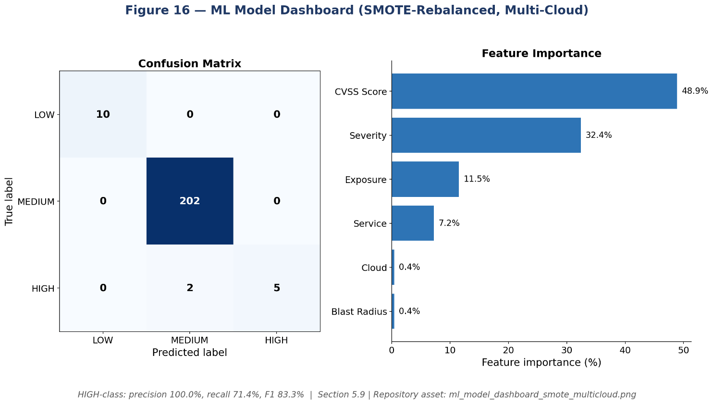
Figure 16: ML Model Dashboard — Confusion Matrix and Feature Importance (Multi-Cloud, SMOTE)
📐 [Diagram recommendation – Before/After SMOTE Comparison (4-panel)]: Class balance and HIGH-class precision/recall, baseline vs. SMOTE, side by side. Repository asset: before_after_smote_comparison.png
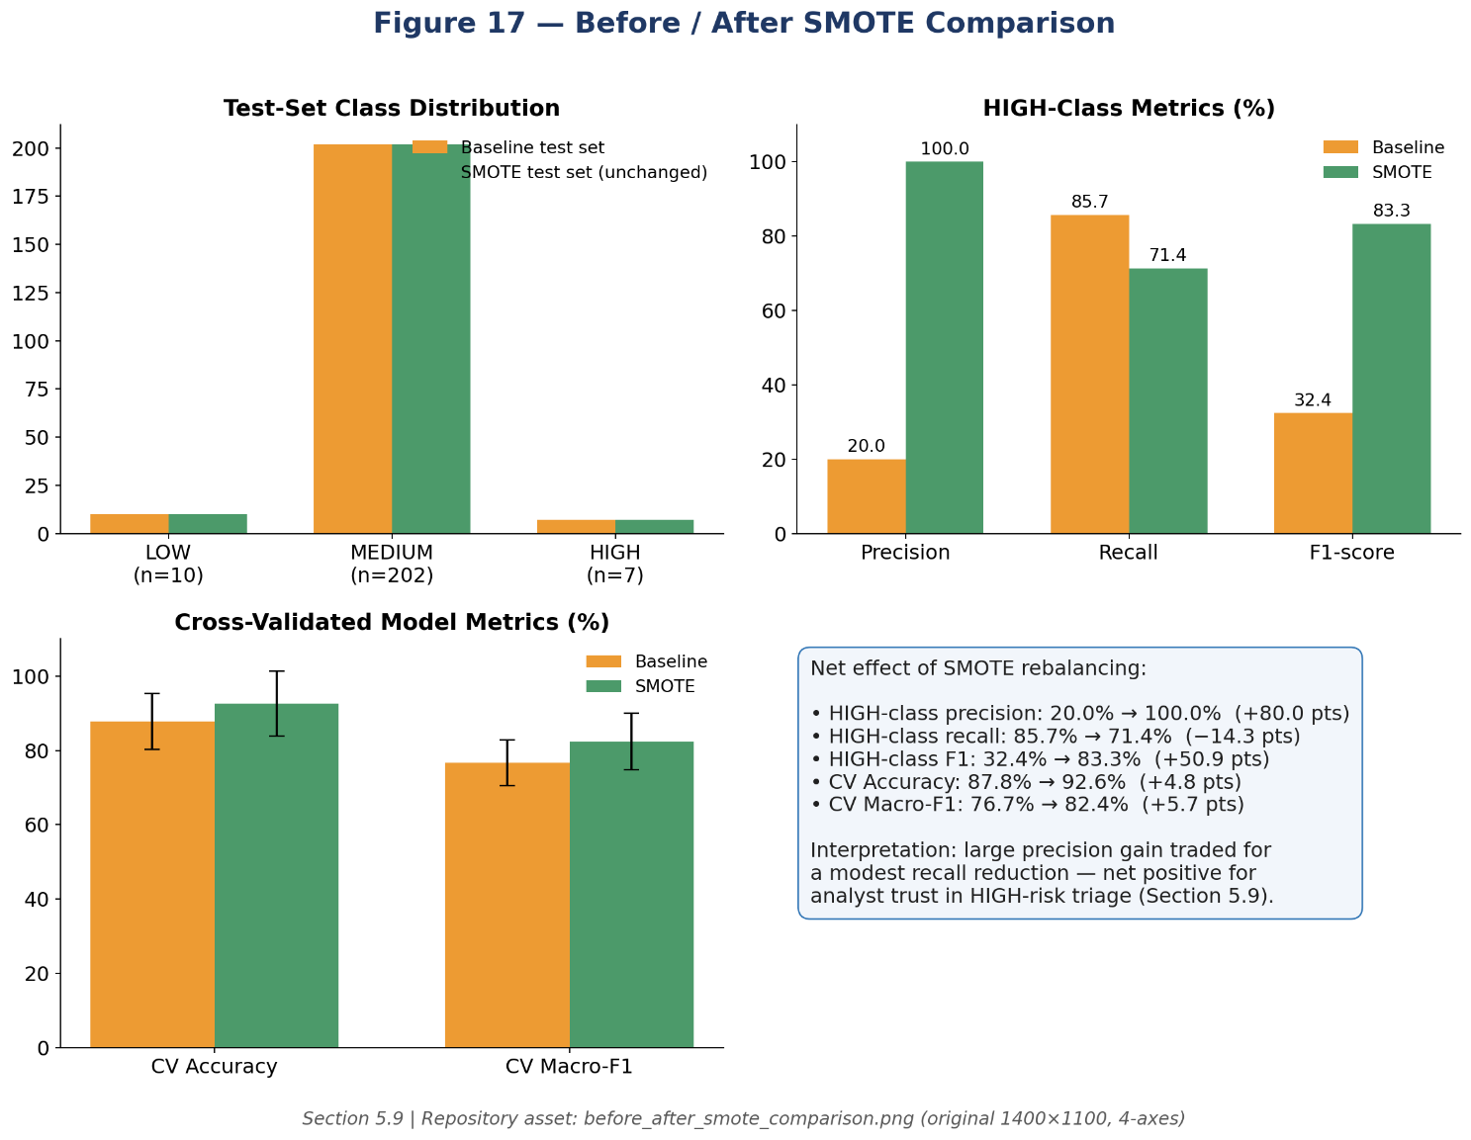
Figure 17: Before/After SMOTE Comparison (4-panel)
📷 [Insert Screenshot – Week 2 CSPM Findings Dashboard – Severity Mix, Top Services, AWS/Azure Split | Repo evidence: 2.Week2/week2_dashboard.png]

5.10 OWASP LLM06-Aligned Redaction Engine
Before any finding data was sent to an external LLM API, an `OWASPRedactionEngine` class scanned and redacted sensitive infrastructure identifiers, directly implementing the OWASP Top 10 for LLM Applications risk LLM06 (Sensitive Information Disclosure). The engine applies twenty ordered pattern categories, from most to least specific, to avoid partial/incorrect matches (e.g., matching a full ARN before its embedded account ID separately).
Table 15: Redaction categories and volumes (167 identifiers redacted across 13 categories, per project verification report)
Category | Count
Subnet IDs | 57
AWS Secret Keys | 27
Security Group IDs | 21
VPC IDs | 18
Network ACL IDs | 18
Project Resource Names | 15
IPv4 Addresses | 3
Azure Subscription IDs | 3
Instance ID | 1
IAM ARN | 1
RDS Endpoint | 1
Volume ID | 1
Account ID | 1
Source (repository): week2_notebook.ipynb — Cell 9, OWASPRedactionEngine (pattern categories, illustrative excerpt)
class OWASPRedactionEngine:
"""
OWASP LLM06 (Sensitive Information Disclosure) mitigation.
Design principles: defense in depth, least exposure, referential
integrity (pseudonymous token mapping so redacted values can still
be cross-referenced within a session), and full auditability.
"""
PATTERNS = [
("AWS_ACCESS_KEY", r"AKIA[0-9A-Z]{16}"),
("AWS_SESSION_TOKEN", r"ASIA[0-9A-Z]{16,}"),
("PRIVATE_KEY_BLOCK", r"-----BEGIN[ A-Z]*PRIVATE KEY-----"),
("JWT_TOKEN", r"eyJ[A-Za-z0-9_-]+\.[A-Za-z0-9_-]+\.[A-Za-z0-9_-]+"),
("IAM_ARN", r"arn:aws:iam::\d{12}:\S+"),
("GENERIC_ARN", r"arn:aws:[a-z0-9-]+:[a-z0-9-]*:\d{12}:\S+"),
("INSTANCE_ID", r"i-[0-9a-f]{8,17}"),
("SECURITY_GROUP_ID", r"sg-[0-9a-f]{8,17}"),
("NETWORK_ACL_ID", r"acl-[0-9a-f]{8,17}"),
("VOLUME_ID", r"vol-[0-9a-f]{8,17}"),
("SUBNET_ID", r"subnet-[0-9a-f]{8,17}"),
("VPC_ID", r"vpc-[0-9a-f]{8,17}"),
("AZURE_SUBSCRIPTION_ID", r"[0-9a-f]{8}-[0-9a-f]{4}-[0-9a-f]{4}-[0-9a-f]{4}-[0-9a-f]{12}"),
("ACCOUNT_ID", r"\b\d{12}\b"),
("IPV4_ADDRESS", r"\b(?:\d{1,3}\.){3}\d{1,3}\b"),
("EMAIL_ADDRESS", r"[\w\.-]+@[\w\.-]+\.\w+"),
# ... additional categories omitted for length; 20 total in source
]
def redact(self, text):
token_map, redacted = {}, text
for label, pattern in self.PATTERNS:
redacted = self._replace_with_token(redacted, label, pattern, token_map)
return redacted, token_map
📷 [Insert Screenshot – Redaction Proof Sample – Before/After Comparison of a Redacted IAM Finding | Repo evidence: 2.Week2/llm-outputs/owasp_redaction_proof.csv]

5.11 RAG-Based Remediation Guidance
Purpose: generate plain-English, framework-cited remediation guidance for the highest-priority findings without exposing raw infrastructure data to a third-party LLM, and without accepting model output on trust.
Table 16: RAG pipeline configuration
Component | Configuration
LLM | meta/llama-3.1-8b-instruct via NVIDIA NIM API
Retriever | Hybrid TF-IDF + NVIDIA NIM embeddings, cosine similarity
Knowledge base | 25 chunks across 6 frameworks: CIS Benchmarks, Microsoft Cloud Security Benchmark, ISO/IEC 27001:2022, DPDP Act 2023, HIPAA — in-house paraphrased text, no live web scraping (offline-safe, reproducible)
Retrieval gate | similarity ≥ 0.30 to accept a candidate chunk
Stage A verification | control-text grounding similarity ≥ 0.55
Stage B verification | raw-finding-data grounding similarity ≥ 0.35
Scope processed | Top 15 priority findings
Verified automatically | 14 of 15 (93%)
Sample verified output (FND-0300, RDS Instance Publicly Accessible): rag_control_ref = "AWS-RDS-01, AWS-RDS-02, AWS-RDS-03"; rag_framework = "AWS Well-Architected Framework — Security Pillar, CIS AWS Foundations Benchmark v5.0.0"; verify_reason = "control_grounding[embedding]=sim=0.5798 thr=0.55 (PASS) | raw_data_grounding[embedding]=sim=0.6012 thr=0.35 (PASS)"; verified = "YES – REVIEW RECOMMENDED (P0)". The one unverified finding of the 15 was correctly routed to manual analyst review rather than silently accepted — this fail-safe design is the central safeguard against LLM hallucination in a security-critical workflow.

5.12 Semi-Automatic Remediation — Lambda Functions (Complete Source)
Three Lambda functions were implemented, each independently dry-run-tested before any live execution, sharing a single IAM role scoped to only the seven permissions required across all three functions — no function has more access than its specific task needs.
Source (repository): 3.Week3/1.semi-automatic/2.iam_role/main.tf — shared least-privilege role (complete policy statement)
resource "aws_iam_role" "remediation_lambda_role" {
name = "cloudguardian-remediation-lambda-role"
assume_role_policy = jsonencode({
Version = "2012-10-17"
Statement = [{ Effect = "Allow", Principal = { Service = "lambda.amazonaws.com" }, Action = "sts:AssumeRole" }]
})
}
resource "aws_iam_role_policy_attachment" "basic_execution" {
role = aws_iam_role.remediation_lambda_role.name
policy_arn = "arn:aws:iam::aws:policy/service-role/AWSLambdaBasicExecutionRole"
}
resource "aws_iam_role_policy" "remediation_permissions" {
name = "cloudguardian-remediation-permissions"
role = aws_iam_role.remediation_lambda_role.id
policy = jsonencode({
Version = "2012-10-17"
Statement = [{
Effect = "Allow"
Action = [
"s3:GetBucketPublicAccessBlock", "s3:PutBucketPublicAccessBlock",
"s3:GetEncryptionConfiguration", "s3:PutEncryptionConfiguration",
"iam:ListAccessKeys", "iam:UpdateAccessKey",
"rds:DescribeDBInstances"
]
Resource = "*"
}]
})
}
Source (repository): 3.Week3/2.automated/remediate_s3_public_access.py — Finding M02/M06 (complete)
"""
CloudGuardian Auto-Remediation: S3 Public Access Block
Finding: M02/M06 - S3 bucket public-access-block disabled | Severity: HIGH
Safe because: Re-enabling public-access-block is NON-DESTRUCTIVE and
REVERSIBLE. It only blocks NEW public ACLs/policies from taking effect; it
does not delete any data, objects, or existing bucket configuration.
"""
import boto3, logging, json
from datetime import datetime, timezone
from botocore.exceptions import ClientError
logger = logging.getLogger(); logger.setLevel(logging.INFO)
s3 = boto3.client("s3", region_name="ap-south-1")
def validate_event(event):
bucket_name = event.get("bucket_name")
if not bucket_name or not isinstance(bucket_name, str):
raise ValueError("Missing or invalid 'bucket_name' in event input")
dry_run = event.get("dry_run", True)
if not isinstance(dry_run, bool):
raise ValueError("'dry_run' must be a boolean")
return bucket_name, dry_run, event.get("requested_by", "unknown")
def log_action(action, bucket_name, requested_by, dry_run, result="SUCCESS", detail=""):
entry = {"timestamp": datetime.now(timezone.utc).isoformat(), "action": action,
"finding": "M02-S3-PUBLIC-ACCESS-BLOCK", "resource": bucket_name,
"requested_by": requested_by, "dry_run": dry_run, "result": result, "detail": detail}
logger.info(json.dumps(entry)); return entry
def lambda_handler(event, context):
try:
bucket_name, dry_run, requested_by = validate_event(event)
except ValueError as e:
return {"statusCode": 400, "body": str(e)}
desired_config = {"BlockPublicAcls": True, "IgnorePublicAcls": True,
"BlockPublicPolicy": True, "RestrictPublicBuckets": True}
try:
current = s3.get_public_access_block(Bucket=bucket_name)
current_config = current["PublicAccessBlockConfiguration"]
except ClientError as e:
code = e.response["Error"]["Code"]
if code == "NoSuchPublicAccessBlockConfiguration": current_config = {}
elif code == "NoSuchBucket": return {"statusCode": 404, "body": f"Bucket '{bucket_name}' not found"}
elif code == "AccessDenied": return {"statusCode": 403, "body": f"Access denied: {e}"}
else: return {"statusCode": 500, "body": f"Unhandled: {code}"}
if current_config == desired_config:
log_action("no_op", bucket_name, requested_by, dry_run, "SKIPPED", "Already fully enabled")
return {"statusCode": 200, "body": "Already remediated - no action needed"}
if dry_run:
log_action("dry_run_remediate", bucket_name, requested_by, dry_run, "SIMULATED", f"Would apply: {desired_config}")
return {"statusCode": 200, "body": f"[DRY RUN] Would enable full public access block on '{bucket_name}'"}
try:
s3.put_public_access_block(Bucket=bucket_name, PublicAccessBlockConfiguration=desired_config)
log_action("remediate", bucket_name, requested_by, dry_run, "SUCCESS", f"Applied: {desired_config}")
return {"statusCode": 200, "body": f"Public access block enabled on '{bucket_name}'"}
except ClientError as e:
code = e.response["Error"]["Code"]
if code == "AccessDenied":
return {"statusCode": 403, "body": "Access denied - Lambda role needs s3:PutBucketPublicAccessBlock"}
return {"statusCode": 500, "body": str(e)}
Source (repository): 3.Week3/2.automated/remediate_iam_key_rotation.py — Finding M01 (complete)
"""
CloudGuardian Auto-Remediation: IAM Exposed Access Key
Finding: M01 - IAM wildcard permissions / exposed access key | Severity: CRITICAL
Safe because: We DEACTIVATE (not delete) the key — instantly reversible by
an admin, unlike deletion which is permanent.
"""
import boto3, logging, json
from datetime import datetime, timezone
from botocore.exceptions import ClientError
logger = logging.getLogger(); logger.setLevel(logging.INFO)
iam = boto3.client("iam")
def validate_event(event):
user, key = event.get("iam_user_name"), event.get("access_key_id")
if not user or not isinstance(user, str):
raise ValueError("Missing or invalid 'iam_user_name'")
if not key or not key.startswith("AKIA"):
raise ValueError("Missing or invalid 'access_key_id' (must start with AKIA)")
dry_run = event.get("dry_run", True)
return user, key, dry_run, event.get("requested_by", "unknown")
def log_action(action, user, key, requested_by, dry_run, result="SUCCESS", detail=""):
# NOTE: never log the secret access key value, only the key ID
entry = {"timestamp": datetime.now(timezone.utc).isoformat(), "action": action,
"finding": "M01-IAM-EXPOSED-KEY", "iam_user": user, "access_key_id": key,
"requested_by": requested_by, "dry_run": dry_run, "result": result, "detail": detail}
logger.info(json.dumps(entry)); return entry
def lambda_handler(event, context):
try:
user, key, dry_run, requested_by = validate_event(event)
except ValueError as e:
return {"statusCode": 400, "body": str(e)}
try:
keys = iam.list_access_keys(UserName=user)["AccessKeyMetadata"]
except ClientError as e:
code = e.response["Error"]["Code"]
if code == "NoSuchEntity": return {"statusCode": 404, "body": f"IAM user '{user}' not found"}
if code == "AccessDenied": return {"statusCode": 403, "body": "Access denied - needs iam:ListAccessKeys"}
return {"statusCode": 500, "body": str(e)}
matching = next((k for k in keys if k["AccessKeyId"] == key), None)
if matching is None:
return {"statusCode": 404, "body": "Access key not found for given IAM user"}
if matching["Status"] == "Inactive":
log_action("no_op", user, key, requested_by, dry_run, "SKIPPED", "Already inactive")
return {"statusCode": 200, "body": "Key already deactivated - no action needed"}
if dry_run:
log_action("dry_run_remediate", user, key, requested_by, dry_run, "SIMULATED", "Would deactivate")
return {"statusCode": 200, "body": f"[DRY RUN] Would deactivate key '{key}' for user '{user}'"}
try:
iam.update_access_key(UserName=user, AccessKeyId=key, Status="Inactive")
log_action("remediate", user, key, requested_by, dry_run, "SUCCESS", "Key deactivated")
return {"statusCode": 200, "body": f"Access key '{key}' deactivated for user '{user}'."}
except ClientError as e:
code = e.response["Error"]["Code"]
if code == "AccessDenied":
return {"statusCode": 403, "body": "Access denied - needs iam:UpdateAccessKey"}
return {"statusCode": 500, "body": str(e)}
Source (repository): 3.Week3/2.automated/remediate_default_encryption.py — Finding M07/M09 (complete)
"""
CloudGuardian Auto-Remediation: Default Encryption (S3 / RDS)
Finding: M07/M09 | Severity: HIGH
Safe because: enabling default SSE is NON-DESTRUCTIVE for S3 — it only
affects NEW objects. RDS encryption CANNOT be toggled on a live instance
without a snapshot-restore (disruptive) — that case is explicitly routed
to "requires human approval", never auto-remediated.
"""
import boto3, logging, json
from datetime import datetime, timezone
from botocore.exceptions import ClientError
logger = logging.getLogger(); logger.setLevel(logging.INFO)
s3 = boto3.client("s3", region_name="ap-south-1")
rds = boto3.client("rds", region_name="ap-south-1")
def remediate_s3(resource_id, dry_run, requested_by):
try:
current = s3.get_bucket_encryption(Bucket=resource_id)
if current["ServerSideEncryptionConfiguration"]["Rules"]:
return {"statusCode": 200, "body": "Already encrypted - no action needed"}
except ClientError as e:
code = e.response["Error"]["Code"]
if code != "ServerSideEncryptionConfigurationNotFoundError":
return {"statusCode": 500 if code != "AccessDenied" else 403, "body": str(e)}
if dry_run:
return {"statusCode": 200, "body": f"[DRY RUN] Would enable default encryption on '{resource_id}'"}
s3.put_bucket_encryption(
Bucket=resource_id,
ServerSideEncryptionConfiguration={"Rules": [{"ApplyServerSideEncryptionByDefault": {"SSEAlgorithm": "AES256"}}]},
)
return {"statusCode": 200, "body": f"Default encryption (AES256) enabled on '{resource_id}'"}
def remediate_rds(resource_id, dry_run, requested_by):
"""RDS: detect and flag only — snapshot-restore is disruptive, so this
branch NEVER auto-remediates, regardless of dry_run."""
response = rds.describe_db_instances(DBInstanceIdentifier=resource_id)
instance = response["DBInstances"][0]
if instance.get("StorageEncrypted", False):
return {"statusCode": 200, "body": "Already encrypted - no action needed"}
return {"statusCode": 200, "body": f"RDS instance '{resource_id}' is unencrypted. "
f"Requires snapshot-restore (disruptive) — routed to human approval, NOT auto-remediated."}
def lambda_handler(event, context):
resource_type = event.get("resource_type")
resource_id = event.get("resource_id")
dry_run = event.get("dry_run", True)
requested_by = event.get("requested_by", "unknown")
if resource_type == "s3":
return remediate_s3(resource_id, dry_run, requested_by)
return remediate_rds(resource_id, dry_run, requested_by)

5.12.1 Dry-Run and Live Execution Evidence
All three functions were dry-run tested first (JSON responses confirming "[DRY RUN] Would..." messages for each), then executed live against real test resources. Live evidence: SNS publish confirmed (MessageId 001c118c-35ff-519e-9b78-735fa7921aff, 17 Jul 2026 02:14:53 UTC); post-remediation state check on bucket `cloudguardian-data-8b63b854` confirmed all four PublicAccessBlockConfiguration flags = true at 02:16:24 UTC, independently reconfirmed via `aws s3api get-public-access-block`.
📷 [Insert Screenshot – CloudWatch Logs – Live S3 Public-Access-Block Remediation Execution | Repo evidence: 3.Week3/1.semi-automatic/3.test_evidence/3.cloudwatch_logs/]
📷 [Insert Screenshot – Before/After Bucket State – S3 Console Showing Public Access Now Blocked | Repo evidence: 3.Week3/1.semi-automatic/3.test_evidence/2.real_run/screenshots/]

5.13 Governed Auto-Remediation — Human-Approval Pipeline
The semi-automatic Lambda functions were extended into a governed pipeline (3.Week3/2.automated, 31 Terraform resource blocks) that inserts a mandatory human-approval gate before any live remediation executes, using AWS Step Functions' waitForTaskToken pattern, SNS for notification, and API Gateway (HTTP API) to receive the approver's click. 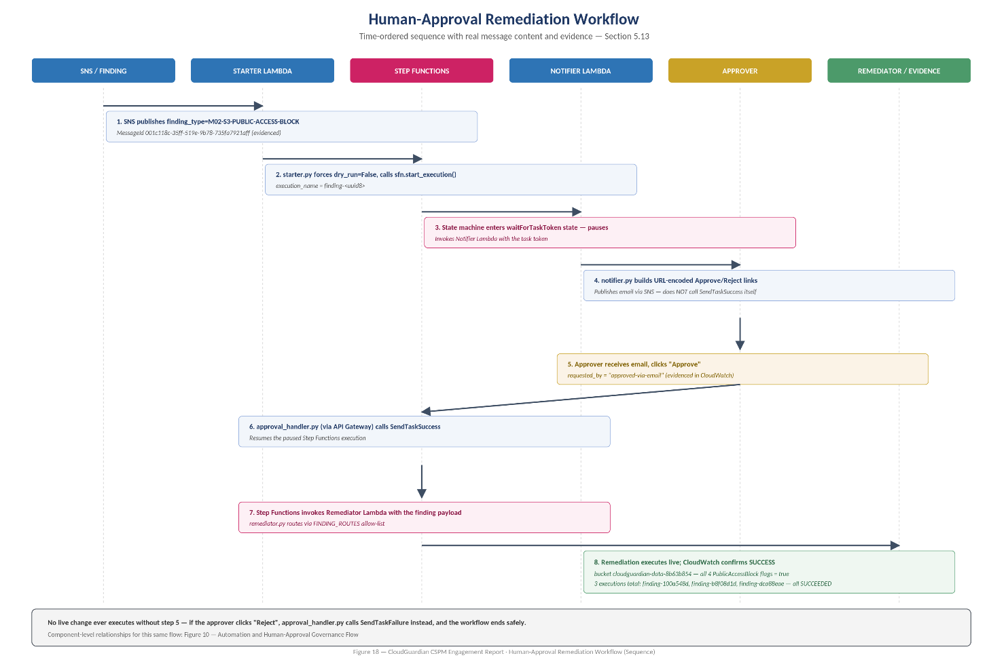

📐 [Diagram recommendation – Human-Approval Remediation Workflow]: SNS finding → Starter Lambda starts Step Functions execution (dry_run forced False) → Step Functions pauses (waitForTaskToken) → Notifier Lambda emails Approve/Reject links → Approval Handler Lambda (via API Gateway) calls SendTaskSuccess/SendTaskFailure → on approval, Remediator Lambda dispatches to the correct handler → CloudWatch evidence.
Figure 18: Human-Approval Remediation Workflow
Source (repository): 3.Week3/2.automated/remediator.py — unified dispatcher with explicit allow-list (complete)
"""
CloudGuardian Auto-Remediation: Unified Dispatcher
Single Lambda entry point triggered via SNS. Routes to the correct
remediation handler by finding_type. Supports direct test invoke AND
real SNS-triggered invocation (event["Records"][0]["Sns"]["Message"]).
"""
import json, logging
import remediate_s3_public_access, remediate_iam_key_rotation, remediate_default_encryption
logger = logging.getLogger(); logger.setLevel(logging.INFO)
# Explicit allow-list (NOT dynamic dispatch) so an unrecognized finding_type
# can never accidentally execute unintended code.
FINDING_ROUTES = {
"M02-S3-PUBLIC-ACCESS-BLOCK": remediate_s3_public_access.lambda_handler,
"M01-IAM-EXPOSED-KEY": remediate_iam_key_rotation.lambda_handler,
"M07-M09-DEFAULT-ENCRYPTION": remediate_default_encryption.lambda_handler,
}
def _extract_payload(event):
if isinstance(event, dict) and "Records" in event:
try:
return json.loads(event["Records"][0]["Sns"]["Message"])
except (KeyError, IndexError, json.JSONDecodeError) as e:
raise ValueError(f"Malformed SNS event: {e}")
elif isinstance(event, dict):
return event
raise ValueError("Event must be a dict")
def lambda_handler(event, context):
try:
payload = _extract_payload(event)
except ValueError as e:
return {"statusCode": 400, "body": str(e)}
finding_type = payload.get("finding_type")
handler = FINDING_ROUTES.get(finding_type)
if handler is None:
return {"statusCode": 400, "body": f"Unknown finding_type '{finding_type}'. Known: {list(FINDING_ROUTES.keys())}"}
return handler(payload, context)
Source (repository): 3.Week3/2.automated/starter.py — begins Step Functions execution on SNS trigger (complete)
"""
CloudGuardian Approval Workflow - Starter Lambda
Subscribed to the SNS topic that used to trigger remediation directly.
Now it starts a Step Function execution instead, which pauses for
human approval before remediating.
"""
import boto3, json, os, logging, uuid
logger = logging.getLogger(); logger.setLevel(logging.INFO)
sfn = boto3.client("stepfunctions")
STATE_MACHINE_ARN = os.environ["STATE_MACHINE_ARN"]
def lambda_handler(event, context):
for record in event.get("Records", []):
finding = json.loads(record["Sns"]["Message"])
execution_name = f"finding-{uuid.uuid4().hex[:8]}"
finding["dry_run"] = False
logger.info(json.dumps({"action": "start_approval_workflow",
"execution_name": execution_name, "finding": finding}))
sfn.start_execution(stateMachineArn=STATE_MACHINE_ARN,
name=execution_name, input=json.dumps(finding))
return {"statusCode": 200, "body": "Approval workflow(s) started"}
notifier.py is invoked BY Step Functions as a waitForTaskToken task: it builds URL-encoded Approve/Reject links embedding the task token and publishes them via SNS email — it deliberately does not call SendTaskSuccess itself, keeping the approval decision strictly in the hands of the human recipient. approval_handler.py is triggered by API Gateway when the approver clicks a link, and resumes the paused execution via SendTaskSuccess (approve) or SendTaskFailure (reject), returning a simple HTML confirmation page.
Live pipeline evidence: three Step Functions executions (finding-100a548d, finding-b8f08d1d, finding-dca88eae) all reached SUCCEEDED status end-to-end, with the approval email routed to the project's designated approver address and CloudWatch logs confirming the exact structured JSON action record (timestamp, finding type, resource, requested_by="approved-via-email", dry_run=false, result=SUCCESS) for the completed remediation.
📷 [Insert Screenshot – Step Functions Execution Graph – Successful Human-Approved Remediation | Repo evidence: 3.Week3/2.automated/evidence/]
📷 [Insert Screenshot – Approval Email – Approve/Reject Links Generated by Notifier Lambda | Repo evidence: 3.Week3/2.automated/evidence/]

6. Validation, Results, and Findings

6.1 Scan Coverage Results
Two independent Prowler datasets exist in the repository and are both reported here for transparency: full, unscoped account-wide scans, and framework-scoped (ISO 27001 + HIPAA) scans used for the team's own reporting. The two are not directly comparable row-for-row, but both confirm the same qualitative pattern — a large proportion of checks failing pre-remediation, concentrated in IAM, storage, network, and encryption domains.
Table 17: Prowler results — full unscoped account-wide scans (raw CSV row counts)
Environment | Total Checks | PASS | FAIL | MANUAL
AWS baseline | 487 | 183 | 302 | 2
AWS misconfigured | 236 | 110 | 122 | 4
Azure baseline | 192 | 46 | 146 | 0
Azure misconfigured | 195 | 32 | 163 | 0
Table 18: Prowler results — ISO 27001 + HIPAA scoped scans (team reporting figures, misconfigured state)
Environment | Total Checked | PASS | FAIL | Pass Rate
AWS (scoped) | 232 | 110 | 122 | 47.4%
Azure (scoped) | 195 | 32 | 163 | 16.4%
Combined | 431 (429 excl. rounding) | 146 | 285 | 34.0%
Combined severity distribution across the 729 consolidated findings: Critical 17 (AWS 8, Azure 9), High 165 (AWS 70, Azure 95), Medium 515 (AWS 392, Azure 123), Low 32 (AWS 26, Azure 6).

6.2 ScoutSuite Before/After Deltas
Table 19: ScoutSuite — AWS baseline vs. misconfigured (checked/flagged per service)
Service | Baseline Checked/Flagged | Misconfigured Checked/Flagged | Delta
EC2 | 673 / 92 | 706 / 94 | +2 flagged
IAM | 152 / 7 | 152 / 7 | No change
RDS | 7 / 2 | 7 / 4 | +2 flagged
S3 | 13 / 3 | 23 / 4 | +1 flagged
CloudTrail | 17 / 17 (danger) | 25 / 22 (danger) | +5 flagged
VPC | 261 / 207 | 261 / 207 | No change
Table 20: ScoutSuite — Azure baseline vs. misconfigured (checked/flagged per service)
Service | Baseline | Misconfigured | Delta
Network | 48 / 0 | 53 / 5 | New danger-level findings introduced
Storage Accounts | 7 / 3 | 7 / 6 | +3 flagged, danger level
SQL Database | 21 / 12 | 22 / 13 | +1 flagged
RBAC / AAD / Security Center | Unchanged | Unchanged | —
The Azure Prowler delta-findings export independently confirms two checks flipping to "NEW FAIL" after injection: `network_ssh_internet_access_restricted` and `network_subnet_nsg_associated`, both tied directly to the injected NSG misconfiguration.

6.3 ML Prioritization Results (Summary)
Full detail is presented in Section 5.8–5.9; the headline results are restated here as part of the engagement's overall results picture: 88.6% baseline test accuracy, rising to 92.6% ± 8.7% cross-validated accuracy after SMOTE rebalancing; HIGH-class precision improved from 20.0% to 100.0%; an honest ablation study confirmed the model's contribution is not a severity-feature shortcut.

6.4 Remediation Results — Before/After Prowler Evidence
The most direct evidence of remediation effectiveness is a live Prowler re-scan of the same AWS account before and after the semi-automatic Lambda remediations executed (account 735291151388, region ap-south-1; before scan 13 Jul 2026 09:37:50 UTC; after scan 13 Jul 2026 17:35:21 UTC).
Table 21: Prowler before/after remediation — full results
Metric | Before | After | Change
Total findings | 178 | 197 | +19
PASS | 94 | 106 | +12
FAIL | 82 | 89 | +7
MANUAL | 2 | 2 | —
Pass rate | 53.4% | 54.4% | +1.0 pt
Critical FAILs | 4 | 4 | —
High FAILs | 17 | 17 | —
Medium FAILs | 49 | 52 | +3
Low FAILs | 12 | 16 | +4
Reading This Table Correctly
The FAIL count rose alongside PASS because 19 new checks entered scope — almost entirely from the 3 new remediation Lambda functions themselves now being scanned as new AWS resources (9 new PASS, plus 1 new FAIL: cloudwatch_log_group_kms_encryption_enabled, since the Lambdas' own log groups are not KMS-encrypted). This is an honest, traceable side effect of adding infrastructure, not a regression in the resources that were actually targeted for remediation.
The clearest direct evidence of remediation working is qualitative, not just numeric: the check `s3_bucket_policy_public_write_access` remained PASS both before and after, but its underlying status text changed from "does not allow public write access in the bucket policy" to "S3 public access blocked at bucket level" — proof the Lambda function acted on the bucket even though the PASS/FAIL classification itself didn't need to flip. Separately, `s3_account_level_public_access_blocks` remained FAIL both times, correctly reflecting that this specific control sits outside the three Lambda functions' scope and was never claimed as remediated.

6.5 Findings Still Open After Remediation (Transparency)
Consistent with the engagement's scope (three safe, non-destructive remediation functions only), a number of critical findings remained open after the Week 3 remediation pass, and are reported here rather than omitted: the RDS instance `cloudguardian-db` remained publicly exposed (M08, out of scope for auto-remediation since it requires network reconfiguration judgment); the account-wide `AdministratorAccess` policy attachment and inline `*:*` IAM policy on `cloudguardian-web-role` remained in place (M01–M03, deliberately requiring a human decision given the severity of directly modifying IAM permissions on a role); EC2 SSH remained open on instance `i-034e7ac45ac7000f4` (M06); RDS storage and transport encryption remained disabled (M09); an EBS volume (`vol-0a1c0089c4da8ce0d`) remained unencrypted; IMDSv2 remained unenforced (M11); and root-user API usage was observed within the prior 24 hours.

6.6 Compliance Crosswalk Results
All 729 findings were mapped in `crosswalk.csv` (Streamlit tool: `crosswalk_app.py`, TF-IDF + cosine similarity matching) to ISO/IEC 27001:2022 Annex A, the HIPAA Security Rule, CIS Controls v8, and the DPDP Act 2023. Because Prowler has no built-in DPDP Act 2023 framework, the team documented an explicit manual process: unique FAIL findings were extracted from the ISO 27001 scan and mapped to DPDP Section 8(5) obligations using an LLM-assisted mapping prompt, then spot-checked for accuracy — an approach the team's SOP documentation records transparently as a deliberate compensating step rather than an automated, framework-native mapping.
Table 22: Sample compliance crosswalk entries (verbatim structure from crosswalk.csv)
Finding | ISO 27001 | HIPAA | CIS v8 | DPDP Act 2023
rds_publicly_accessible | A.5.15 (Access control) | 164.308(a)(1) | 3.3 | Sec 8(4)
iam_inline_policy_allows_privilege_escalation | A.8.3 | 164.312(a)(1) | 5.4 | Sec 5

6.7 Technical, Business, and Operational Findings

6.7.1 Technical Findings
- No single scanner caught everything: ScoutSuite contributed 55.8% of consolidated findings, Prowler 39.1%, and Steampipe 5.1% — confirming the value of running three tools rather than one, and that different tools frequently disagree on severity for the same underlying issue (e.g., FND-0300 vs. FND-0464, both describing RDS public exposure at different assigned severities).
- Rule-based scoring alone was not sufficient for reliable HIGH-risk triage (20% precision); ML alone without class-imbalance correction was also insufficient; the combination of ML + SMOTE was required to reach a precision level (100%) that would be operationally trustworthy for an analyst.
- LLM-generated remediation guidance required an explicit, non-optional verification gate — one of fifteen generated outputs failed verification and was correctly escalated rather than silently accepted, validating the design decision to never trust LLM output by default in a security context.

6.7.2 Business, Architecture, Security, Operational, and Compliance Findings
- Business: the engagement directly demonstrates, with evidence, how the health-tech case scenario's recurring ISO 27001/HIPAA audit failures could be broken — not through more manual review, but through consolidated detection, explainable prioritization, and safe automation.
- Architecture: identical Terraform-driven baseline/misconfigured stack pairs for both clouds proved to be the single most valuable design decision, since it made every claimed detection independently falsifiable against a known-injected ground truth.
- Security: automating only non-destructive, reversible fixes (public-access-block re-enable, key deactivation, default-encryption enable) while explicitly routing destructive or judgment-requiring changes (RDS re-encryption, IAM permission reduction) to human approval is a defensible, auditable risk posture for a first-generation automation capability.
- Operational: the human-approval workflow (Step Functions/SNS/API Gateway) demonstrates a credible middle ground between fully manual ticketing and fully unsupervised remediation, evidenced by three complete, successful executions.
- Compliance: mapping 100% of findings to four frameworks, including a documented compensating process for the DPDP Act 2023 (which lacks native Prowler support), produced an audit-ready artifact rather than a purely technical output.

6.7.3 Limitations and Trade-offs
- HIGH-class recall dropped from 85.7% to 71.4% after SMOTE — a small number of genuinely HIGH findings would now be missed by the ML layer alone; the rule-based Priority Score remains the safety-net layer for this gap.
- Only 3 of the rubric's 4 target remediation functions were fully implemented and evidenced (all AWS-side); a 4th, Azure-side remediation function was scoped but not completed within the three-week window — reported here rather than implied as complete.
- The blast-radius scoring heuristic uses keyword-based cross-cloud service mapping rather than each provider's native resource-type taxonomy — a documented, acknowledged simplification appropriate to the engagement's scope.
- The DPDP Act 2023 crosswalk relies on a partially manual, LLM-assisted mapping process rather than a scanner-native framework, since no such native framework exists in Prowler at the time of the engagement.
- Compliance-crosswalk matching used TF-IDF/cosine similarity rather than a validated legal-mapping methodology, and should be treated as a strong first-pass artifact requiring compliance-team sign-off before use in an actual audit.

7. Lessons Learned and Future Enhancements

7.1 Lessons Learned
- Negation-aware keyword scoring was not a nice-to-have — an early version of the rule-based scorer materially over-scored secure, PASS-state findings whose text happened to contain risk keywords in a negated sentence; this was caught and fixed before it could distort prioritization.
- An honest ablation study (removing the severity feature and re-training) is a cheap, high-value way to confirm an ML model is contributing genuine signal rather than trivially encoding an existing rule.
- SMOTE materially improved HIGH-class precision but at a real recall cost — reporting both sides of that trade-off, rather than only the headline accuracy improvement, is what makes the result trustworthy.
- Requiring a dual-threshold verification gate on LLM output (control grounding AND raw-data grounding) caught a real failure case (1 of 15 findings) rather than being a theoretical safeguard that never triggers.
- Documenting real deployment friction (a heredoc left open, a missing closing quote around an email address in Terraform, an undeclared variable, an `EntityAlreadyExists` conflict requiring `terraform import`, a missing Lambda zip artifact, confusion between root and a non-privileged Kali user, duplicate notebook cells corrupting the `cloud_provider` column, and AWS silently re-applying AES-256 encryption over the M10 misconfiguration) turned out to be as instructive for a technical reviewer as the successful outcomes.

7.2 Future Enhancements
- Complete the fourth (Azure-side) remediation function to close the gap against the Team-scope rubric's 4-function target.
- Extend the RDS-encryption case beyond "flag for human approval" into an orchestrated, approval-gated snapshot-restore workflow, since the underlying remediation mechanics (snapshot → encrypted copy → restore → DNS/endpoint cutover) are well-understood even though disruptive.
- Replace the keyword-based cross-cloud blast-radius heuristic with each provider's native resource-type/criticality taxonomy.
- Automate the compliance crosswalk verification step (currently TF-IDF similarity plus manual LLM-assisted mapping for DPDP) with a maintained, versioned control-mapping database reviewed by a compliance subject-matter expert.
- Extend the redaction engine and RAG verification pipeline to Azure-native identifier patterns with the same rigor currently applied to AWS ARNs and resource IDs.
- Integrate the Streamlit application with live cloud APIs (rather than CSV upload) for continuous, always-on posture monitoring rather than point-in-time scan analysis.
📐 [Diagram recommendation – CSPM Maturity Roadmap for CloudGuardian]: Current state (manual CSV upload, point-in-time scans, 3 of 4 target remediation functions) → target state (continuous live-API monitoring, full 4-function remediation, automated compliance-mapping refresh).
Figure 19: CSPM Maturity Roadmap for CloudGuardian

8. Comparative Analysis

8.1 AWS vs. Azure — Detection Coverage in This Engagement
Table 23: AWS vs. Azure — findings and severity comparison
Dimension | AWS | Azure
Consolidated findings | 496 (68.0%) | 233 (32.0%)
Critical severity | 8 | 9
High severity | 70 | 95
Medium severity | 392 | 123
Low severity | 26 | 6
Baseline Prowler pass count (scoped) | 110 / 232 | 32 / 195
Terraform resource count (baseline) | 19 | 24
Native DPDP Act 2023 framework support (Prowler) | No — manual/LLM-assisted mapping used | No — manual/LLM-assisted mapping used
Azure's per-finding severity skewed higher (95 High vs. AWS's 70, despite AWS having more than double the total finding count) — largely attributable to the concentrated impact of the Azure misconfiguration set on Network, Storage, and SQL Database services, each of which affected a smaller total resource count than AWS's broader EC2/VPC footprint, so each Azure misconfiguration represented a larger proportional share of that service's checks.

8.2 Rule-Based Scoring vs. ML Classification vs. RAG-Guided Remediation
Table 24: Comparison of CloudGuardian's three prioritization/guidance layers
Layer | Strength | Weakness | Role in Pipeline
Rule-based Priority Score | Fully transparent and auditable; no training data needed | Cannot learn interaction effects between features | Safety-net baseline ranking for every finding
RandomForest + SMOTE | 92.6% CV accuracy; 100% HIGH-class precision post-SMOTE | Recall trade-off (71.4% HIGH recall); needs periodic retraining | Refines the P0/P1 queue for analyst attention
RAG remediation guidance (NVIDIA NIM) | Plain-English, framework-cited guidance at scale | Requires mandatory dual-verification gate to be trustworthy | Accelerates remediation-guidance authoring for top findings

8.3 Semi-Automatic vs. Governed (Human-Approval) Remediation
Table 25: Remediation maturity comparison
Dimension | Semi-Automatic (Week 3 §1) | Governed / Human-Approval (Week 3 §2)
Trigger | Direct Lambda invocation / manual test | SNS event → Step Functions
Human gate | None (dry-run tested, then run manually) | Mandatory — waitForTaskToken pause, email Approve/Reject
Evidence | CloudWatch logs + before/after Prowler scan | 3 completed Step Functions executions, CloudWatch logs
Best suited for | Rapid proof-of-concept validation | Production-representative, auditable operation

9. Business Value and Governance Implications

9.1 Why This Matters for the Case Scenario
The engagement's framing scenario — a health-tech organization repeatedly failing ISO 27001/HIPAA audits — is directly addressed by CloudGuardian's results: consolidated, cross-tool detection closes the "we didn't know" gap; ML-refined prioritization closes the "we didn't know what to fix first" gap; verified RAG guidance closes the "we didn't know how to fix it" gap; and the human-approval remediation pipeline closes the "we were afraid to automate it" gap, without removing human judgment from consequential decisions.

9.2 Executive and Operational Benefits
- Board/audit-ready compliance crosswalk spanning ISO 27001, HIPAA, CIS Controls v8, and DPDP Act 2023 for all 729 findings, rather than a partial or single-framework view.
- A defensible, evidenced automation boundary: only non-destructive, reversible actions are auto-executed; destructive or judgment-dependent actions are routed to a human, with a full audit trail either way.
- A quantified, honestly-reported improvement in triage precision (20% → 100% HIGH-class precision) that would materially reduce wasted analyst effort chasing false-positive critical alerts.

9.3 Cost and Scalability Considerations
The entire pipeline was built and operated within AWS free-tier and Azure trial-subscription limits, using open-source scanning tools (Prowler, ScoutSuite, Steampipe) and a free-tier LLM API (NVIDIA NIM), demonstrating that a meaningful CSPM capability does not require a large upfront tooling investment. The normalized findings schema and modular remediation-function pattern are designed to extend to additional AWS accounts, Azure subscriptions, or additional finding sources without architectural rework — the main scaling constraints identified are the free-tier service quotas rather than the pipeline design itself.

References
[1] Amazon Web Services, "AWS Well-Architected Framework — Security Pillar," AWS Documentation, 2024. Available: https://docs.aws.amazon.com/wellarchitected/latest/security-pillar/
[2] Microsoft, "Microsoft Cloud Security Benchmark," Microsoft Learn, 2024. Available: https://learn.microsoft.com/security/benchmark/azure/
[3] Center for Internet Security, "CIS Amazon Web Services Foundations Benchmark," CIS, 2023.
[4] Center for Internet Security, "CIS Controls v8," CIS, 2021.
[5] International Organization for Standardization, "ISO/IEC 27001:2022 — Information Security Management Systems," ISO, 2022.
[6] U.S. Department of Health and Human Services, "HIPAA Security Rule, 45 CFR Part 164 Subpart C," HHS, 2013 (as amended).
[7] Government of India, "The Digital Personal Data Protection Act, 2023," Ministry of Electronics and Information Technology, 2023.
[8] MITRE Corporation, "MITRE ATT&CK for Cloud," MITRE, 2024. Available: https://attack.mitre.org/matrices/enterprise/cloud/
[9] OWASP Foundation, "OWASP Top 10 for Large Language Model Applications — LLM06: Sensitive Information Disclosure," OWASP, 2023–2024.
[10] Prowler Community, "Prowler Open Source Documentation," 2024–2026. Available: https://docs.prowler.com/
[11] NCC Group / ScoutSuite Contributors, "ScoutSuite Documentation," GitHub, 2024.
[12] Turbot, "Steampipe Documentation," 2024. Available: https://steampipe.io/docs
[13] Chawla, N., Bowyer, K., Hall, L., Kegelmeyer, W., "SMOTE: Synthetic Minority Over-sampling Technique," Journal of Artificial Intelligence Research, vol. 16, pp. 321–357, 2002.
[14] Pedregosa, F. et al., "Scikit-learn: Machine Learning in Python," Journal of Machine Learning Research, vol. 12, pp. 2825–2830, 2011.
[15] Lewis, P. et al., "Retrieval-Augmented Generation for Knowledge-Intensive NLP Tasks," Advances in Neural Information Processing Systems (NeurIPS), 2020.
[16] NVIDIA, "NVIDIA NIM — meta/llama-3.1-8b-instruct Model Card," NVIDIA API Catalog, 2024–2026.
[17] Gartner, "Market Guide for Cloud-Native Application Protection Platforms," Gartner Research, 2023.
[18] Amazon Web Services, "AWS Step Functions Developer Guide — Wait for a Callback with the Task Token," AWS Documentation, 2024.
[19] Cloud Security Alliance, "Security Guidance for Critical Areas of Focus in Cloud Computing v4.0," CSA, 2023.
[20] Vinay Kumar, Megha Sharma, Kedar Pavaskar, "CloudGuardian — AI-Driven Multi-Cloud Misconfiguration Detection, Prioritization & Auto-Remediation," Capstone Project CAP-CSE-3W, IIT Roorkee × Futurense, 2026. Repository: github.com/vkhere/CloudGuardian.

Appendix A — Additional Source Code and Configuration References
Complete source for the highest-value authored files (Terraform network/compute/database/storage/IAM stacks, all three remediation Lambda functions, the unified dispatcher, and the Step Functions starter) is reproduced in full in Section 5. This appendix indexes the remaining authored files retained in the source repository for readers who need the complete file set.
Table 26: Appendix A index — repository file locations
Category | Repository Path
AWS baseline Terraform (complete stack) | 1.Week1/1. AWS/1.baseline/1.terraform/1.1.1.main.tf – 1.1.8.outputs.tf
AWS misconfigured Terraform (complete stack) | 1.Week1/1. AWS/2.misconfig/1.0 Misconfig/1.2.1.main.tf – 1.2.9.cloudtrail.tf
Azure baseline/misconfig Terraform (complete stack) | 1.Week1/2.Azure/1.baseline/1.Terraform/ and 1.Week1/2.Azure/2.Misconfig/1.Terraform/
Week 2 analysis notebook (24 cells, complete) | week2_notebook.ipynb
Streamlit application (2,011 lines, complete) | 4.streamlit_app/app.py
Human-approval pipeline Terraform (31 resources) | 3.Week3/2.automated/remediation.tf, approval.tf, provider.tf
Approval handler and notifier Lambda source | 3.Week3/2.automated/approval_handler.py, notifier.py
Compliance crosswalk tool | 3.Week3/1.semi-automatic/5.compliance_crosswalk/crosswalk_app.py
Detailed remediation technical documentation | 3.Week3/week_3_CloudGuardian_AutoRemediation_Documentation.docx
Deployment SOP (semi-automatic) | 3.Week3/1.semi-automatic/... /3.SOP-semiautomatic.docx

Appendix B — Findings, Evidence, and Test Data Exports
Table 27: Appendix B index — data exports
Artifact | Repository Path | Rows / Scope
Consolidated findings (CSV) | 2.Week2/consolidated_findings.csv (mirrored in 5.Results/) | 729 findings, 28 fields
Consolidated findings (JSON) | 2.Week2/consolidated_findings.json | 729 findings
LLM remediation guidance | 2.Week2/llm_remediation_guidance.csv | Top 15 priority findings
RAG retrieval audit trail | 2.Week2/rag_retrieval_audit.csv | ~14 findings, full retrieval trace
OWASP redaction proof | 2.Week2/llm-outputs/owasp_redaction_proof.csv | 15 sampled findings, full redaction detail
Remediation dry-run log | 2.Week2/remediation_dry_run_log.csv | 15 dry-run entries
Prowler before/after remediation report | 3.Week3/1.semi-automatic/4.prowler_before_after/ | 178→197 total findings
Compliance crosswalk (full) | 3.Week3/1.semi-automatic/5.compliance_crosswalk/crosswalk.csv | 729 rows
Appendix B also includes, at the repository paths above, the full set of screenshot evidence referenced throughout this report (console screenshots for AWS/Azure resource provisioning, ScoutSuite HTML report captures, CloudWatch log screenshots, before/after S3 bucket state screenshots, and Step Functions execution graphs).

Appendix C — Glossary, Acronyms, and Abbreviations
See front-matter Glossary and Acronyms sections for the complete list used consistently throughout this report.

